Warwick District Council’s Events Strategy 2026-2030
Vision
The Council’s vision is to transform public spaces into vibrant places with year-round outdoor events, festivals, and markets—creating experiences that bring people together, celebrate local identity, and strengthen the local economy.
Introduction – where events are now
The purpose of the Events Strategy is to present the strategic direction for outdoor events, to enhance the existing programme of events, while prioritising and planning for future opportunities.
Warwick District has the leading programme in Warwickshire, with around 150 outdoor events taking place across the four towns annually. Events are an important contributor to the area’s cultural life, from community gatherings and special parades to large-scale festivals, their ability to bring parks and public spaces to life, boost footfall, attract tourists and support businesses, are just some of the benefits.
This strategy embraces that potential through thoughtful planning and inclusive growth, while recognising and managing the challenges. It seeks to support community events while pursuing commercial opportunities, ensuring a balanced and sustainable approach to the development of better events.
Aligned with the Council’s ambition to make Warwick District a great place to live, work, and visit, the strategy provides a clear framework to guide decisions over the next four years, that will support the evolving needs of residents, visitors, and businesses.
How this strategy fits into other strategies
This strategy contributes to Priority 1 and Priority 3 of the Council's Corporate Strategy for Warwick District 2030: Priority 3 is particularly relevant.
Priority 3: Creating vibrant, safe and healthy communities of the future
We will work with communities, businesses and public sector partners to enable and support improvements where people’s community, economic and housing needs can be met. This will facilitate a better and more sustainable balance with the natural world that will allow our communities and businesses to thrive in a sustainable and safe way.

The work of the Business Support and Events team’s fits directly into 3.1.1 which seeks to: ‘Enhance our town centres by working with businesses in place making initiatives, events and active travel to support the daytime and nighttime economy.’
What the Council means by ‘events’
Events are defined as ‘an activity that is planned for a special purpose and usually involves a lot of people.’ Set against the backdrop of parks and public spaces, events are shared experiences that bring friends, families, and communities together.
Defining the boundaries of the approach
The strategy focuses on outdoor events held in parks, green spaces, and town centres across publicly owned land. While the Council recognises that many events take place at privately owned venues, this strategy is primarily concerned with those within the Council’s control and influence.

From the outset, it’s important to acknowledge the context: limited resources for event delivery, rising demand and enthusiasm for events, and evolving health and safety requirements. This Strategy sets out the Council’s approach to balancing the number and diversity of events it supports and provides a clear framework for the Business Support & Events team to manage that balance effectively.
Team overview
Since a team dedicated to facilitating events was first created in 2010, the numbers of events have grown from 60 annually, rising to 128 just five years later. Post pandemic recovery has seen a strong return for the outdoor events sector locally, to a new high of around 150 events annually. During this time of significant growth, the teams’ resources have consistently remained at four staff (three officers and a manager), and recently the team has been joined by an Events Assistant. While events form a large part of the team’s work, the team is also responsible for other services including the town’s Markets, Film and TV bookings, Promotional Stands and Street Parties.
Appendix 1: Research & Analysis covers the context in more detail, including the range of challenges facing high streets and how events can help face these, the venues where events take place and how events are classified.

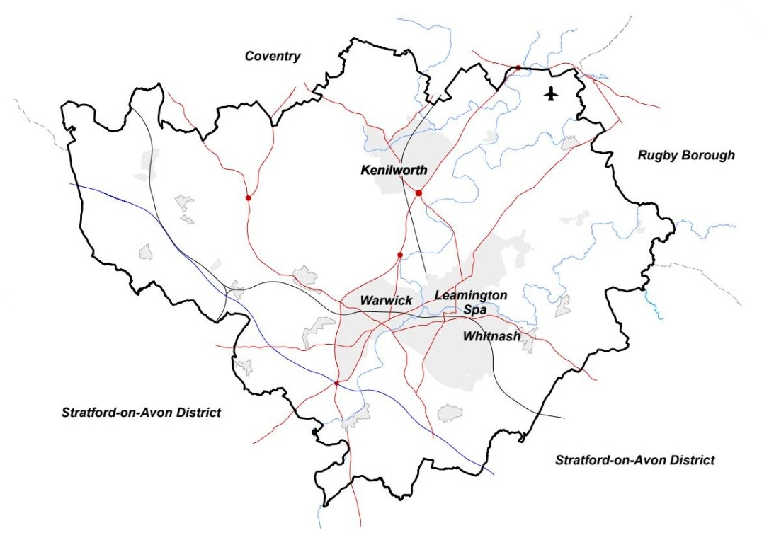

Principles
The following seven guiding principles inform the approach:
- Celebrate local identity through inclusive and accessible events.
- Work together with partners and event organisers to support vibrant towns and thriving local businesses.
- Nurture sustainable events to manage and to minimise environmental impact.
- Balance commercial ambition with strong support for community events.
- Measure economic and social impact using data and evidence.
- Deliver exceptional event experiences through continuous review and improvement.
- Safety and security are fundamental to everything.

What challenges will this Strategy help solve?
The Strategy positively contributes to several key challenges in society and communities. These include:
- Supporting high street businesses with a vibrant programme of events to attract footfall and increase vibrancy.
- Fostering community cohesion by creating opportunities for different members of the community to meet and share space.
Further key challenges and how the Strategy will address these have been outlined in full detail in Appendix 3: Supporting information to accompany the Events Strategy.

Where does the Council want to be?
By 2030 the district will have a national profile and recognition for the quality of events hosted here. It will be a leading local authority organisation in events management, which will attract exciting and innovative events to take place here.
This will be achieved through having a supportive, structured process that is user-friendly helping event organisers, community groups and commercial companies to deliver successful events. Dedicated events spaces will be maintained in town centres, parks and urban spaces enabling organisers to have access to a range of suitable venues.
The Council will build upon an already impressive reputation, to facilitate events which above all positively contribute to people, place and planet.
The strategy will be delivered through six priorities:
Key Priority 1 – Contribution to Placemaking
Description | Events, festivals and markets can make an important contribution to placemaking by activating spaces, giving people extra reasons to visit, all of which helps to increase footfall, dwell time and vibrancy to support town centres.  For further info, see academic research section in Appendix 1: Research & Analysis.
What’s  going to be done | - Imaginatively use town centre spaces for events, to ‘pull’ visitors into town, focused on creating experiences.  - Develop programme of Winter events to ensure towns are activated year-round.  - Measure economic and social impact using data and evidence.  - Review and improve events organised by the Council, such as the Christmas Light switch-ons.  - Develop new events specifically for children and young people.  - Prioritise events that bring together different groups to help with community cohesion.  - Programme high-quality Headline events to attract wider audiences beyond the local area.
How success will be measured | - Impact on the high streets in terms of busier, more vibrant places.  - Increased footfall and extra visitors.  - Publicity about the town’s events.  - Current low vacancy rates in shops monitored and maintained.  - Calendar full year-round with diverse range of events.
Risks | Managing the adverse effects of events on residents and businesses.
Issues to overcome | Resources and time within the Council to implement new ideas and improve offering. Funding required for research.

Key Priority 2 – Financial Sustainability
Description | To facilitate the current level of events, while managing growth and demand for more, the Council must ensure this is financially viable long term.
What’s  going to be done | - Host Headline events which contribute to the services income.  - Introduce new ‘Parks Levy’ for ticketed commercial events that will financially contribute to park maintenance.  - Explore sponsorship as a financial model for supporting community events.  - Identify new opportunity areas for holding events.  - Continue to support and develop the existing range of markets.  - Promote the district as an area for filming.  - Expand stock of available kit for events, that can be hired.
How success will be measured | - Income targets achieved.  - Service area is fully resourced and able to meet increased demand for events, markets and filming.
Risks | Income can vary depending on number of commercial events booked. Park and town centre space availability at peak times. Team needs sufficient resources to manage quantity of events across the towns.
Issues to overcome | Fees and charges to remain competitive. Other neighbouring towns improving their own offering.

Key Priority 3 – Balancing Community and Commercial
Description | To have a healthy and sustainable programme, the right balance of community and commercial events is essential.  For further info see Appendix 1: Research & Analysis on Community Vs Commercial
What’s  going to be done | - Find a balance between commercial hire of public spaces and the need for residents and visitors to have free access to these areas most of the time.  - Increase ratio of commercial events from 27% (in 2024) to 40% gradually over the next four years, to enable the Council to financially support community events through lower fees.  - Commit to ensuring the majority of events remain free, or low cost to attend.
How success will be measured | - Diverse annual programme of events which has a mix of community and commercial events.  - Continual reflection and improvement to manage the balance.
Risks | Events will continue to generate some complaints, but the risk of not holding some commercial events in public parks and spaces would be worse for the towns overall – footfall reduction, businesses not being supported.
Issues to overcome | Perceptions of events being ‘too commercial’. Misunderstandings around the commercialisation of public spaces to be overcome through improved communication of the reasons and benefits for holding events.

Key Priority 4 – Operational Improvements
Description | The Council are committed to providing a quality service area dedicated to facilitating outdoor events, which is designed to support event organisers through the process from initial application to event day and beyond.  In addition to the already established processes outlined in Appendix 2: Policies, the following operational improvements are proposed.
What’s  going to be done | - Develop a new Events Charter of key criteria that applications should meet to be accepted.  - Introduce new events categories and associated fees.  - Manage diaries with other departments and venues to avoid clashes wherever possible.  - Update event forms when the approach, processes or relevant legislation changes.  - Digitise the application process.  Marketing & Communication  - Improve communication with partners organisations.  - Market events through different mediums to increase awareness of ‘what’s on’.  - Support event organisers with a new communication guide in partnership with the Media team.  - Improve WDC website pages.  - Explore advertising opportunities in billboards /carparks/noticeboards.  - Collaborate with stakeholders to share event information across websites and social media.
How success will be measured | - Event organisers benefit from a modern process which balances the need for regulation while providing a comprehensive, user-friendly service.  - Clearer event categories help with classification, fees and charges.  - Application process is open and transparent through the Events Charter.  - Reduced paperwork and chasing for documents improves efficiency.
Risks | Reliance on other teams’ availability to assist. Resistance to change.
Issues to overcome | Resources and time required to implement the changes.

Key Priority 5 – Safety and Security
Description | The Council is committed to working in partnership with internal departments and partners at other agencies to manage the risks while continuing to facilitate events in public spaces. Further information on safety can be found in Appendix 3: Supporting Information.  To maintain and improve the safety culture in the district, the following are priorities:
What’s  going to be done | - Hold regular Safety Advisory Group meetings to scrutinise and advise ‘large scale’ public events.  - Continue to be an active member of the Warwickshire Events Safety Partnership.  - Work in partnership with WDC Emergencies and Resilience, Community Safety, CCTV and partner agencies such as the Police and Local Resilience Forum.  - Research and implement necessary changes to Hostile Vehicle Mitigation (HVM) requirements.  - Scrutinise and advise event organisers on their risk assessments, event management plans and documents, putting safety and security above all other considerations.  - Implement changes as required for Martyn’s Law.
How success will be measured | - Record and monitor number of incident reports and near misses.
Risks | Some risk of harm or issues at events will remain.
Issues to overcome | Resourcing any necessary changes. Significant financial implications if HVM needs to be hired or purchased.

Key Priority 6 – Sustainability and the Environment
Description | Many parks in the district are award winning and listed which is something to be proud of. To ensure these spaces continue to be cared for, Council teams work together to take reasonable steps to protect the environment when parks are used for temporary events. The Council will encourage events to continually improve their environmental and sustainability efforts.
What’s  going to be done | - Support events which have an environmental theme, that aligns with the Council’s ambitions around the climate emergency.  - Give positive encouragement to events which provide opportunities locally, where otherwise people may have to travel greater distances.  - Book ‘rest days’ into the calendar to give the ground time to recover.  - Protect the biodiversity of meadows and trees, by checking the suitability of events in different locations.  - Grass kept relatively long by contractors to protect the ground from footfall and vehicles.  - Tracking used to protect the park from heavy vehicles.  - Reduce impact on wildlife through careful scheduling to avoid nesting times.  - Update Parks Protocols to show new areas and utilities info.  - Research the Green Code of Practice and adopt practical elements.  - Research assessment tools that can support events to improve their environmental practices.  - Issue alert advice to manage risks from fire, weather and heat health.  - Continued learning on the environment, sustainability and climate action.  - Improve infrastructure in the park, to reduce use of generators.
How success will be measured | - Monitoring the Council’s ability to maintain a programme of events in the parks, while also allowing time for the spaces to be freely open for all activities.
Risks | Cancellation or postponements due to weather or ground conditions being unsuitable. Parks may need longer recovery periods if damaged by an event.
Issues to overcome | Climate change affecting the parks and their ability to host events. Some events may be unable to continue due to environmental issues. Funding required for infrastructure improvements.

Further opportunities
There are several exciting projects happening in the district, which have the potential to open further opportunity areas for outdoor events, these include:
- Parade Regeneration, Leamington Spa town centre.
- Tachbrook Country Park, new 49-hectare country park linking Bishops Tachbrook, Whitnash, Leamington Spa and Warwick.
- Elizabeth Park, new public park linking Leamington Spa and Warwick.
- Community Stadium, new community hub for sport, leisure and other health related provision on Europa Way/Gallows Hill, Leamington Spa.
Within the next four years, these projects could provide substantial new spaces for events, leisure and other activities for the public to use. To ensure that the most benefit can be gained from these opportunities, an Activation Plan will be developed, in conjunction with relevant officers and stakeholders with a focus initially on Parade as this space is currently used for outdoor events.
Making it happen
To deliver against each of the six identified priorities, an internal Action Plan forms the basis of the Business Support & Events team’s work over the next four years. The Action Plan will include a summary, key performance indicators, outcome/successes, estimated timescales and a priority rating to help with planning time and resources.
Some recommendations are short-term actions; others are long-term projects and goals to work towards. Each action states whether resources and funding are available already or will be required. This will remain a live action plan, which is updated regularly as the need arises.

Ongoing review
The strategy will be kept under regular review every two years, with monitoring and evaluation undertaken against the priorities (see Appendix 2). The strategy and supporting appendices have been prepared in the context of the current and emerging market for outdoor events and will continue to respond to the needs of the place, its people, the environment, businesses, the events industry, changes to legislation and any proposed political reforms.
For comments on the Events Strategy, please write to: events@warwickdc.gov.uk. The current programme of events can be found on the Councils What’s On guide.
Thanks and acknowledgments
Many thanks to the following people and organisations for the support provided in the formation of the Events Strategy.
Strategy and planning: Martin O’Neill, Business Manager Projects and Economic Development, Philip Clarke, Head of Place, Arts & Economy, Darren Knight, Deputy Chief Executive.
Business Support and Events team: Louise Sheepy, Gary Rudd, Charlie Sabin (Events Officers) and Rachael Millington (Events Assistant).
Colleagues: Arts, Assets, Climate Change, Contract Services, Community Safety, Economic Development, Emergencies & Resilience, Environmental Protection, Green Spaces, Health & Safety, Insurance & Risk, Licensing, Media & Designers, Parking, Projects, Sport & Leisure.
Stakeholders, advisors & organisations: Warwick District Council, Leamington Town Council, Kenilworth Town Council, Warwick Town Council, Whitnash Town Council, BID Leamington, Friends of Groups.
Strategy author: Charlotte Sully, Business Support & Events Team Manager
Supporting documents
- Appendix 1: Summary of Research & Analysis
- Appendix 2: Policies
- Appendix 3: Supporting information to accompany Events Strategy

