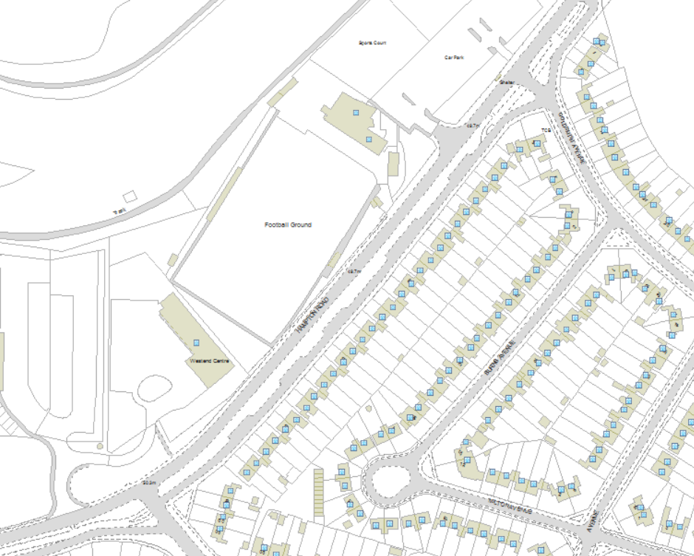
Hampton Road Wildflower Verge Trial Area

