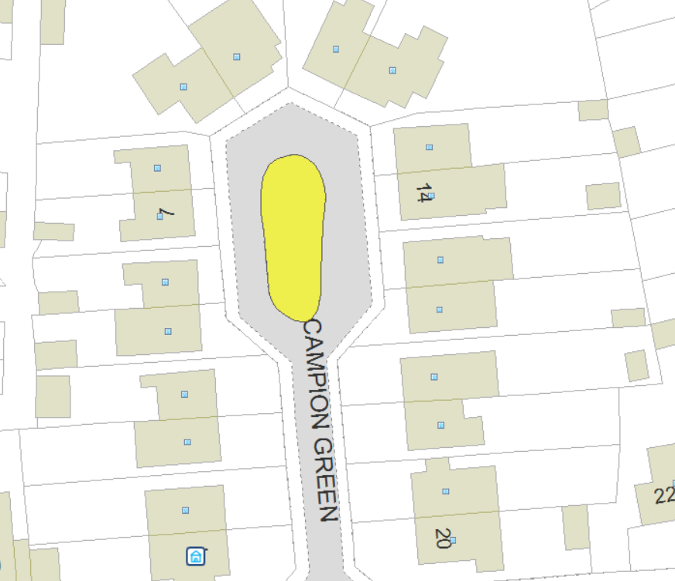
Proposed Wildflower Verge
Area to remain as close mown grass

Applicant: Warwick District Council
Village / Town: Leamington Spa
Road Name: Campion Green

Proposed Wildflower area
50m squared
Approx 10m x 5m

Tree with bench underneath

