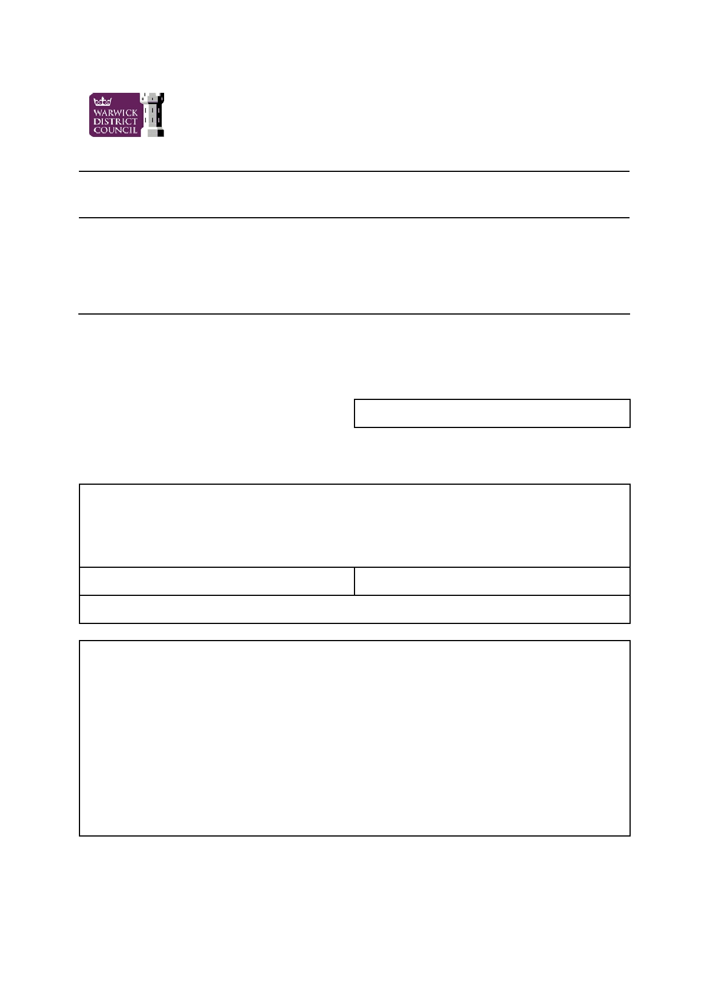
Reference :

Licensing, Town Hall, Parade, Royal Leamington Spa, CV32 4AT

Application to vary a premises licence to specify an individual as designated
premises supervisor under the Licensing Act 2003

PLEASE READ THE FOLLOWING INSTRUCTIONS FIRST

Before completing this form please read the guidance notes at the end of the form. If you are completing this form by hand please write legibly in block capitals. In all cases ensure your answers are inside the boxes and written in black ink. Use additional sheets if necessary. You may wish to keep a copy of the completed form for your records.

I/We ………………………………………………………. (full name(s) of premises licence holder) being the
premises licence holder, apply to vary a premises licence to specify the individual named in
this application as the premises supervisor under section 37 of the Licensing Act 2003

Premises licence number

Part 1 - Premises Details

Postal address of premises or, if none, ordnance survey map reference or description

Post town Post code

Telephone number (if any)

Description of premises (please read guidance note 1)

Page 1 of 3

Part 2

Full name of proposed designated premises supervisor

Personal licence number of proposed designated premises supervisor and issuing authority of
that licence (if any)

Place of Birth and Date of Birth;

Full name of existing designated premises supervisor (if any)

I would like this application to have immediate effect under section 38 of the Licensing
Act 2003
I have enclosed the premises licence or relevant part of it

If you have not enclosed the premises licence, or relevant part of it, please give reasons why
not

Reasons why I have failed to enclose the premises licence or relevant part of it

• I have made or enclosed payment of the fee
• I will give a copy of this application to the chief officer of police
• I have enclosed the consent form completed by the proposed premises supervisor
• I have enclosed the premises licence or relevant part of it or explanation
• I will give a copy of this form to the existing premises supervisor, if any
• I understand that if I do not comply with the above requirements my application will be rejected

IT IS AN OFFENCE, LIABLE ON CONVICTION TO A FINE UP TO LEVEL 5 ON
THE STANDARD SCALE, UNDER SECTION 158 OF THE LICENSING ACT 2003
TO MAKE A FALSE STATEMENT IN OR IN CONNECTION WITH THIS
APPLICATION

Page 2 of 3

Part 3 - Signatures (please read guidance note 10)

Signature of applicant or applicant's solicitor or other duly authorised agent. (See guidance note 3). If signing on behalf of the applicant please state in what capacity.

Signature ………………………………………………………………………………………………………..

Date ………………………………………………………………………………………………………………

Capacity ……………………… ………………………………………………………………………………..

For joint applications signature of 2nd applicant or 2nd applicant's solicitor or other authorised
agent. (please read guidance note 4). If signing on behalf of the applicant please state in what capacity.

Signature ………………………………………………………………………………………………………..

Date ………………………………………………………………………………………………………………

Capacity ……………………… ………………………………………………………………………………..

Contact Name (where not previously given) and address for correspondence associated with
this application (please read guidance note 5)

Post town Post code

Telephone number (if any)

If you would prefer us to correspond with you by e-mail your e-mail address (optional)

Notes for guidance

1.

2.

3.

4.

5.

Describe the premises. For example the type of premises it is.

The application form must be signed.

An applicant's agent (for example solicitor) may sign the form on their behalf provided that they have actual authority to do so.

Where there is more than one applicant, both applicants or their respective agents must sign the application form.

This is the address which we shall use to correspond with you about this application.

Page 3 of 3

