Rose & Crown – outside dining

The Rose & Crown, 30 Market Place, Warwick, CV34 4SH
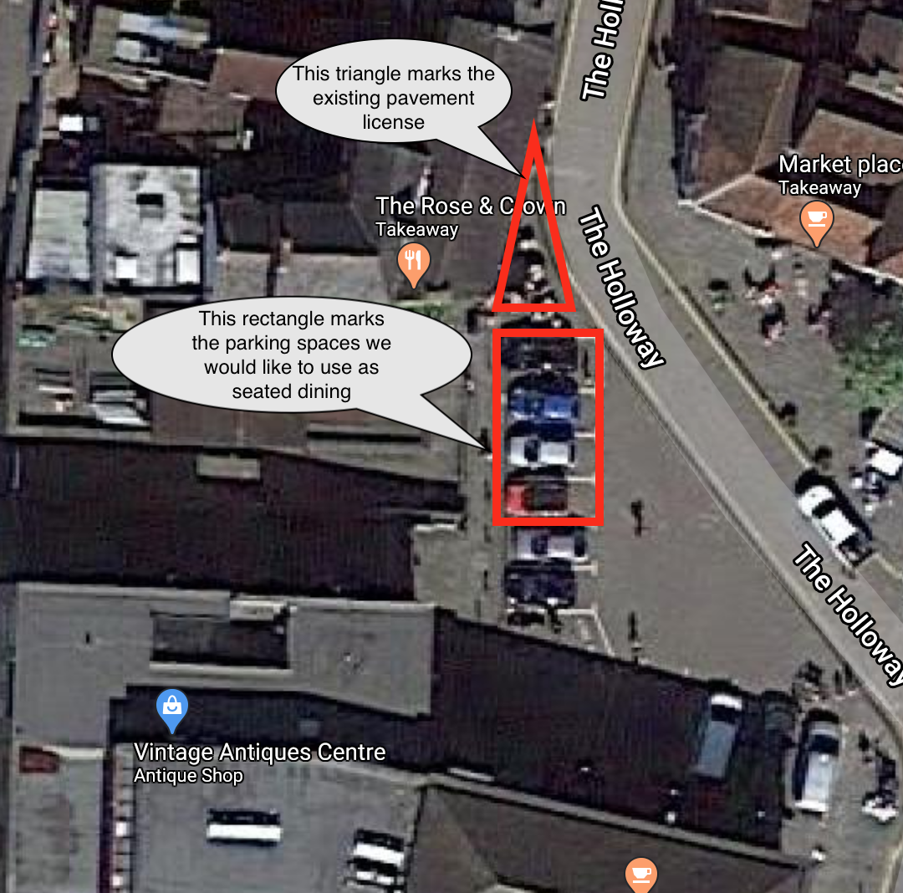

Proposed Table Layout
The parking bay is protected at both ends by an increased width in the pavement which keeps this stretch out of the main run of traffic.
These tables would be served in line with our attached new operational policy.
