Interests Flowchart
The flowchart below gives a simple guide to declaring an interest under the code.
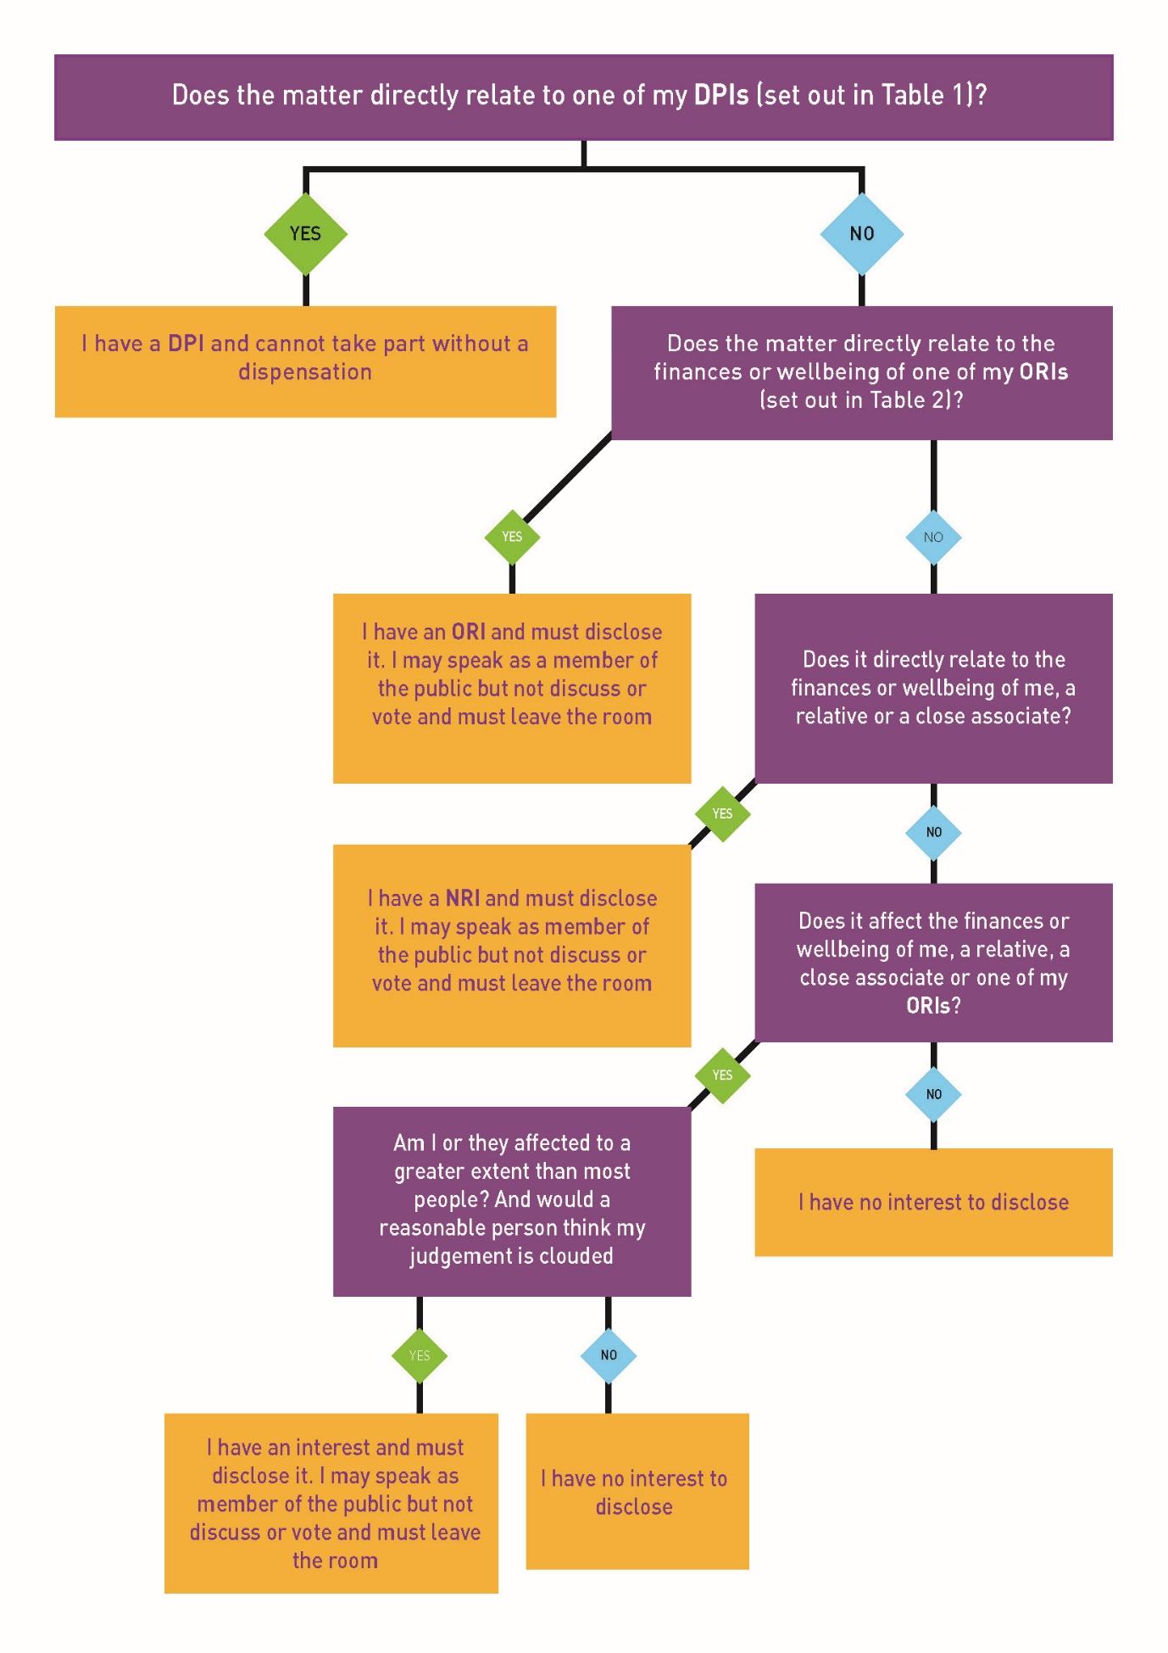
https://www.local.gov.uk/publications/guidance-local-government-association-model-councillor-code-conduct#declarations-of-interest

