WARWICK DISTRICT COUNCIL

AUDIT OF ACCOUNTS YEAR ENDED 31 MARCH 2021
Publication of Warwick District Council Statement of Accounts and Audit Opinion

The Accounts and Audit Regulations 2015 – Regulation 10, as amended by The Accounts and Audit (Amendment) Regulations 2021

The Accounts and Audit (Amendment) Regulations 2021 require that the audited accounts and opinion are published by 30 September 2021. As at 30 September, the Council’s external auditor, Grant Thornton UK LLP, has not yet concluded the audit.

The delay has arisen due to a combination of factors, comprising the following:
- The external auditors, Grant Thornton LLP, have experienced resourcing challenges during the audit process.
- Work on areas of the audit have taken Grant Thornton LLP longer than in previous years, including Property, Plant & Equipment valuations, Bank Reconciliation, and Grant Income (largely relating to Covid specific grants)
- The Council have experienced associated delays in responding to audit requests due to Grant Thornton’s resourcing challenges and the result of a delay to receiving an agreed audit plan.

The Council is continuing to work closely with the audit team as they complete their work. In line with the Accounts and Audit Regulations 2015, the Council has published a set of draft accounts. The Council will publish a final set of accounts as soon as the audit is concluded, and the Audit Report is issued.

Warwick District Council’s Finance & Audit Scrutiny Committee was formally advised of this matter on 22 September 2021.

This notice of delayed audit is being published in accordance with Regulation 10, paragraph (2a) of the Accounts and Audit Regulations 2015.

Date: 30 September 2021.

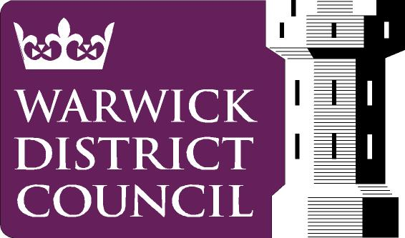
Mike Snow
Chief Financial Officer
Warwick District Council
Riverside House
Milverton Hill
Royal Leamington Spa
CV32 5HZ www.warwickdc.gov.uk

