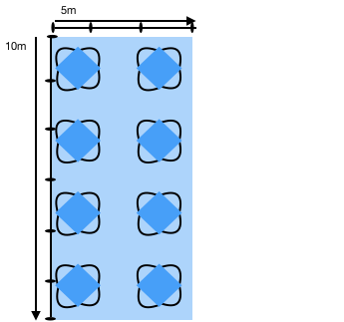

Each parking space is 2.5m (W) x 5m (L)
Total area of 4 parking spaces is 10m (W) & 5m (L)

Each table is 79cm square
Each chair is 48 cm (W)

