WARWICK DISTRICT COUNCIL

AUDIT OF ACCOUNTS YEAR ENDED 31 MARCH 2021
NOTICE OF PUBLIC RIGHTS

The Accounts and Audit Regulations 2015
The Local Audit and Accountability Act 2014
The Accounts and Audit (Amendment) Regulations 2021

Notice is hereby given under Regulation 15(2)(b) of the Accounts and Audit Regulations 2015 that from 19 July to 20 August 2021 between 9.00am and 4.45pm on weekdays any person may inspect, and make copies of the accounts and all books, deeds, contracts, bills, vouchers, receipts and other related documents of the Council for the year ended 31 March 2021, as stipulated in Section 25 of the Local Audit and Accountability Act 2014. Commercially confidential and personal information is exempt from inspection as provided for in Section 26(4) to 26(6) of the Local Audit and Accountability Act 2014 in relation to. The accounts will be available for electronic inspection at: http://www.warwickdc.gov.uk/info/20733/council_policies_and_plans/389/statement_of_accounts. Other access requests, such as to view documents in person, will be subject to the latest Government social distancing policy and premises being open to the public. Please telephone 01926 456013 if you wish to discuss specific requirements.

During this period, a local government elector for any area to which the accounts relate, or their representative, may question the auditor about the accounts, or make an objection to the accounts as set out in sections 26 and 27 of the Local Audit and Accountability Act 2014. Any objection, and the grounds on which it is made, must be sent to the auditor in writing, with a copy to Mike Snow, Chief Financial Officer, Warwick District Council, Riverside House, Milverton Hill, Royal Leamington Spa, CV32 5HZ. Any objection must state the grounds on which the objection is being made and particulars of:

- any item of account which is alleged to be contrary to law; and
- any matter in respect of which it is proposed that the auditor could make a public interest report under section 24 of, and paragraph 1 of Schedule 7 to, the Local Audit and Accountability Act 2014.

Objections should be addressed to the auditor, Grant Thornton UK LLP at The Colmore Building, 20 Colmore Circus, Birmingham, West Midlands, B4 6AT.

A guide to your rights can be found at https://www.nao.org.uk/code-audit-practice/council-accounts-a-guide-to-your-rights/council-accounts-a-guide-to-your-rights-2/

Please note that the public inspection period has been amended in accordance with Regulation 2 of the Accounts and Audit (Amendment) Regulations 2021. The deadline for local authorities must commence the period for the exercise of public rights – which normally must include the first 10 working days of June – has been extended and must commence on or before the first working day of August 2021. Regulation 2 of these amendments extend the final deadline for the Council to publish the complete, audited 2020/21 Statement of Accounts from 31 July 2021 to 30 September 2021.

Date: 19 July 2021.

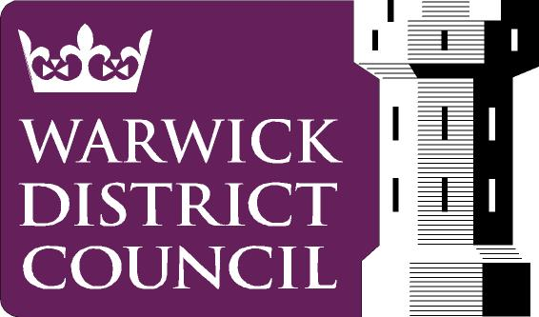
Mike Snow
Chief Financial Officer
Warwick District Council
Riverside House
Milverton Hill
Royal Leamington Spa
CV32 5HZ www.warwickdc.gov.uk

Our Privacy Notice is overleaf

The following Privacy Notice applies to Warwick District Council’s Accountancy Service
The personal data that you provide will be used to enable us to contact yourself and respond to your Inspection Questions and the legal basis for this processing is under sections 26 and 27 of the Local Audit and Accountability Act 2014.
Failure to provide contact details means that the Council will not be able to respond to you.
Your personal data will be kept for 6 Financial Years plus the current one.
You have the right to access your personal data and to complain if you think your data is being used incorrectly. You may also have other rights, such as to have your data corrected or erased.
For full details on your personal data rights please see the Council’s main Privacy Notice on https://www.warwickdc.gov.uk/privacynotices
For further advice visit www.ico.org.uk or for independent advice about data protection, privacy and data sharing issues contact the Information Commissioner’s Office.
For the Data Controller and Data Protection Officer’s contact details and further information please see the Council’s main Privacy Notice on www.warwickdc.gov.uk

