Rustic Food Drawing/Plans
 | RUSTIC FOOD
Wall | Front Door |  | Shop Windows
 | Small Step |  |  | 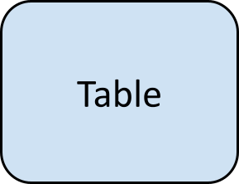
Pavement (2.33m)
 |  |  |  | Table to Pavement (1.83m)
 |  |  |  |  |  |  | Illustrations (Key)
Regent Street (Road)
 |  |  |  |  |  |  | C (Chair) | 75cm (h) x 48cm (w)
 |  |  |  |  |  |  | Table | 75cm (h) x 50cm (w)
 |  |  |  |  |  |  | Distance in Length

