WARWICK DISTRICT COUNCIL

AUDIT OF ACCOUNTS YEAR ENDED 31 MARCH 2020
STATUTORY DEADLINE EXTENSIONS

The Accounts and Audit Regulations 2015
The Local Audit and Accountability Act 2014
The Accounts and Audit (Coronavirus) (Amendment) Regulations 2020

Please note – due to the Coronavirus (COVID-19) pandemic, the Government has extended the statutory deadline for the public inspection of the Council’s 2019/20 Statement of Accounts, in accordance with 2(4) of the Accounts and Audit (Coronavirus) (Amendment) Regulations 2020.
The deadline for local authorities must commence the period for the exercise of public rights – which normally must include the first 10 working days of June – has been extended and must commence on or before 1st September 2020. Regulations 2(2) of these amendments extend the final deadline for the Council to publish the complete, audited 2019/20 Statement of Accounts from 31st July 2020 to 30th November 2020.
Both amendments were introduced to provide local councils with a degree of flexibility, to mitigate the potential disruption that would be caused by the spread of coronavirus.
As per the regulations the Council will publish a notice to confirm the period of inspection.

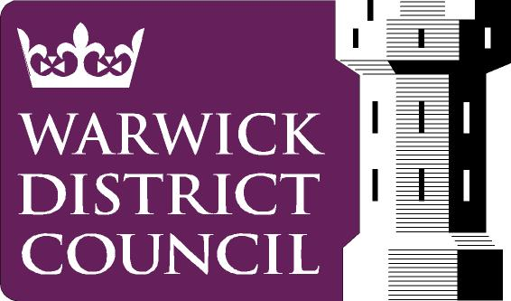
Date: 29th May 2020.

www.warwickdc.gov.uk

