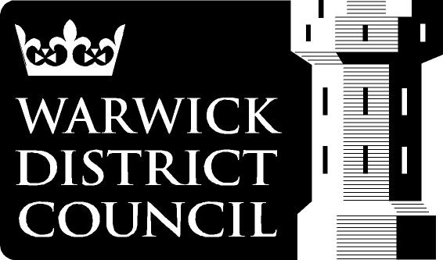
EDMONDSCOTE ATHLETICS TRACK
SEASON TICKET APPLICATION FORM

In order to obtain a season ticket for Edmondscote Athletics Track please complete the following information and send with 1 passport size photo to: Cultural Services, Riverside House, Milverton Hill, Leamington Spa, Warwickshire, CV32 5HZ

- FULL NAME OF APPLICANT _________________________________________________

- CORRESPONDENCE ADDRESS______________________________________________

__________________________________________________________________________

TEL. No. (Home)________________ (Work)________________ (Mobile)________________

Email Address _____________________________________________________________

- Sex (please circle) Male Female

- Date of Birth _________________ Junior’s are 18 and under

- EMERGENCY CONTACT

Name ____________________________________________________________________

TEL. No. (Home)________________ (Work)________________ (Mobile)________________

- TYPE OF MEMBERSHIP REQUIRED (please circle price)

Adult Full Season £125.00 Valid 1st April 2020 to 31st March 2021

Adult ½ Season £50.00 Valid 1st Oct 2020 to 31st March 2021 only

Junior/Senior Full Season £63.00 Valid 1st April 2020 to 31st March 2021

Junior/Senior ½ Season £25.20 Valid 1st Oct 2020 to 31st March 2021 only

PLEASE MAKE ALL CHEQUES PAYABLE TO WARWICK DISTRICT COUNCIL

- MEDICAL CONDITIONS

If you have any medical conditions that the staff need to be aware of please give details below.

I agree to abide by the rules of Edmondscote Athletics Track

Signed _________________________________ Date.__________________

Return form to: Warwick District Council, Cultural Services, Riverside House, Milverton Hill, Leamington Spa Warwickshire, CV32 5HZ

