PERMIT TO TRADE FORM
FOR TEMPORARY PREMISES SELLING FOOD &/OR DRINK INTENDING to TRADE IN WARWICK DISTRICT

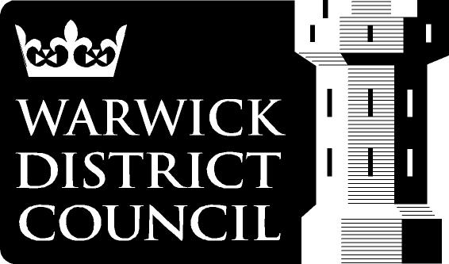

This permit will remain valid for the duration of the calendar year for 2024.

Trading Name: | Event(s) Attending:
Proprietor:(Full Name)  Address:  Contact mobile number: | Name of Local Authority with which you are registered:  What is your National Food Hygiene Rating?  Date of issue:  Sale /supply of alcohol only:  Name of Designated Premises Supervisor:
Email address:

List of foods and or drinks being provided, including samples:

Are you a: -  Mobile:  (Vehicle registration number)  Stall Marquee  What precautions do you take for adverse weather? | Number of Staff:  Open Food handling only:  Food hygiene training certification/ experience for those attending the event:  (NCASS, Level 2, SFBB, In house)
Detail your hand hygiene facilities:
Detail your equipment washing facilities/arrangements: | Detail your arrangements to inform customers about allergens:  (Signage, menu, allergen matrix, verbal)

1. What food safety management system do you follow?
NCASS/SFBB/Safe Catering/Cooksafe/ HACCP plans

1a. What supplementary records do you keep?

2. What COVID Secure controls have you put in place at the stall.
3. How is potable water supplied to the unit?
4. What cleaning regime is in place for cold water containers ?
5. How is hot water provided to your unit?

6. What do you do with your waste water?
7. What cleaning materials do you use?

Are they accredited to BS EN1276:2009 or BS EN 13697:2001?
8. What protective clothing is worn by your staff?
9. What advice do you give to staff about what to do if they are suffering from sickness & diarrhoea?
10. How do you protect ready to eat foods from physical /microbial contamination during storage, display?

11. What equipment do you have to keep food cold at 8◦C or below? and for monitoring storage temperatures?
12. How do you check that foods are thoroughly cooked and kept at above 63◦C?

13. What precautions are taken to control acrylamide levels?
14. Detail your first aid arrangements?

15. How is power supplied to the stall/ unit? Mains power/ generator?

What safety checks are carried out?

15. What fire extinguisher do you have and how many?

16. Do you use LPG cylinders?  Yes No  How many? | If yes, you must carry out a fire risk assessment, keep the number of cylinders to a minimum, keep rubbish and combustible materials away from the cylinders, protect the cylinders and connections from damage and do not smoke when changing them.
17. Will the LPG cylinder be used in an open air installation?  Yes No | If yes, you must ensure the cylinder is fitted in an upright position and protected against damage. The cylinder must be sited below any adjacent opening of the vehicle, or there must be at least 1metre horizontal distance between openings of adjacent buildings, or sources of ignition.
18. Will the LPG cylinder be stored inside a trailer?  Yes No | If yes, the cylinder must be kept in a compartment which has 30mins fire resistance with high and low level ventilation. Access to the cylinder must be from the outside of the vehicle by a lockable door. The compartment must be gas tight to the interior of the unit and the cylinder must be securely fastened during transit. Signage eg “Extremely Flammable LPG” needs to be displayed on the outside of the bottle compartment.
19. Is the LPG hose BS 3212:91, in good condition and regularly checked for leaks using soapy water?  Yes No | If no, the flexible hose must be replaced and must be secured with proper LPG hose clips. Leak checks using soapy water need to be regularly carried out. The flexible hose should be kept to a minimum.
20. Is your gas catering appliance fitted with a flame failure device  Yes No | If no, gas appliances must be fitted with a flame failure device by a gas safe engineer, www.gassaferegister.co.uk
21. Is your gas catering appliance regularly checked by a gas safe engineer registered for LPG appliances  Yes No | If no, appoint a competent engineer registered for LPG appliances www.gassaferegister.co.uk

For further clarification and information regarding food safety requirements and facilities to be provided you should refer to Warwick District Councils ‘Standard for Temporary Premises & Stalls at Markets & Events’ or contact the Food Safety Team direct on 01926-456713.

PLEASE RETURN THIS FORM IN ADVANCE OF TRADING AT THE MARKET OR EVENT. THE FOLLOWING SELF-CERTIFICATION SHOULD BE COMPLETED IN CONJUNCTION WITH THE WARWICK DISTRICT COUNCIL’S ‘STANDARD FOR TEMPORARY PREMISES & STALLS AT MARKETS AND EVENTS ETC’

Warwick District Council, Riverside House, Milverton Hill, Royal Leamington Spa, CV32 5QF
Tel 01926 45713, Foodsafety@warwickdc.gov.uk

Sustainability – Plastics Policy

Warwick District Council has adopted a Plastics Policy which commits to avoid plastics with a particular focus on the elimination of the use of single use plastics. Our Plastics Policy can be viewed on our website:

www.warwickdc.gov.uk/downloads/file/5200/plastics_policy

Events taking place on Warwick District Council owned land must be single-use plastic free where practicable and our events team are able to support in this area. If the event is not taking place on Warwick District Council owned land, we strongly encourage events to be single-use plastic free where practicable.

We are currently developing guidance to support organisers’ of events on alternatives to single-use plastic and when this is published, it will be available to view on our website.

www.warwickdc.gov.uk/info/20796/town_centres_and_events

