WARWICK DISTRICT COUNCIL

AUDIT OF ACCOUNTS YEAR ENDED 31st MARCH 2019
NOTICE OF PUBLIC RIGHTS

The Accounts and Audit Regulations 2015
The Local Audit and Accountability Act 2014

Notice is hereby given under Regulation 15(2)(b) of the Accounts and Audit Regulations 2015 that from 1 June to 12 July, 2019 between 9.00am and 4.45pm on weekdays any person may inspect, and make copies of the accounts and all books, deeds, contracts, bills, vouchers, receipts and other related documents of the Council for the year ended 31st March 2019, as stipulated in Section 25 of the Local Audit and Accountability Act 2014. The accounts and other documents will be available for inspection at Warwick District Council, Riverside House, Milverton Hill, Royal Leamington Spa, CV32 5QW by prior arrangement. Please telephone 01926 456013 to make an appointment. The accounts will also be available at http://www.warwickdc.gov.uk/info/20733/council_policies_and_plans/389/statement_of_accounts.

During this period, a local government elector for any area to which the accounts relate, or their representative, may question the auditor about the accounts, or make an objection to the accounts as set out in sections 26 and 27 of the Local Audit and Accountability Act 2014. Any objection, and the grounds on which it is made, must be sent to the auditor in writing, with a copy to Mike Snow, Chief Financial Officer, Warwick District Council, P.O. Box 2180, Riverside House, Milverton Hill, Royal Leamington Spa, CV32 5QW. Any objection must state the grounds on which the objection is being made and particulars of:
- any item of account which is alleged to be contrary to law; and
- any matter in respect of which it is proposed that the auditor could make a public interest report under section 24 of, and paragraph 1 of Schedule 7 to, the Local Audit and Accountability Act 2014.

Objections should be addressed to the auditor, Grant Thornton UK LLP at The Colmore Building, 20 Colmore Circus, Birmingham, West Midlands, B4 6AT.

A guide to your rights can be found at https://www.nao.org.uk/code-audit-practice/wp-content/uploads/sites/29/2015/03/Council-accounts-a-guide-to-your-rights.pdf
Date: 31 May 2019.

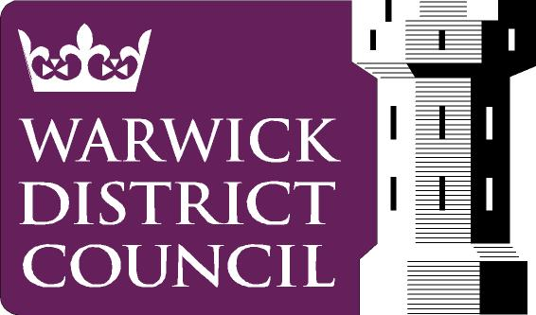
Mike Snow
Chief Financial Officer
Warwick District Council
Riverside House
Milverton Hill
Royal Leamington Spa
CV32 5QW www.warwickdc.gov.uk

Our Privacy Notice is overleaf

The following Privacy Notice applies to Warwick District Council’s Accountancy Service
The personal data that you provide will be used to enable us to contact yourself and respond to your Inspection Questions and the legal basis for this processing is under sections 26 and 27 of the Local Audit and Accountability Act 2014.
Failure to provide contact details means that the Council will not be able to respond to you.
Your personal data will be kept for 6 Financial Years plus the current one.
You have the right to access your personal data and to complain if you think your data is being used incorrectly. You may also have other rights, such as to have your data corrected or erased.
For full details on your personal data rights please see the Council’s main Privacy Notice on https://www.warwickdc.gov.uk/privacynotices
For further advice visit www.ico.org.uk or for independent advice about data protection, privacy and data sharing issues contact the Information Commissioner’s Office.
For the Data Controller and Data Protection Officer’s contact details and further information please see the Council’s main Privacy Notice on www.warwickdc.gov.uk

