Warwick District Council
Community Infrastructure Levy Regulation 62 Monitoring Report
April 2017 / March 2018
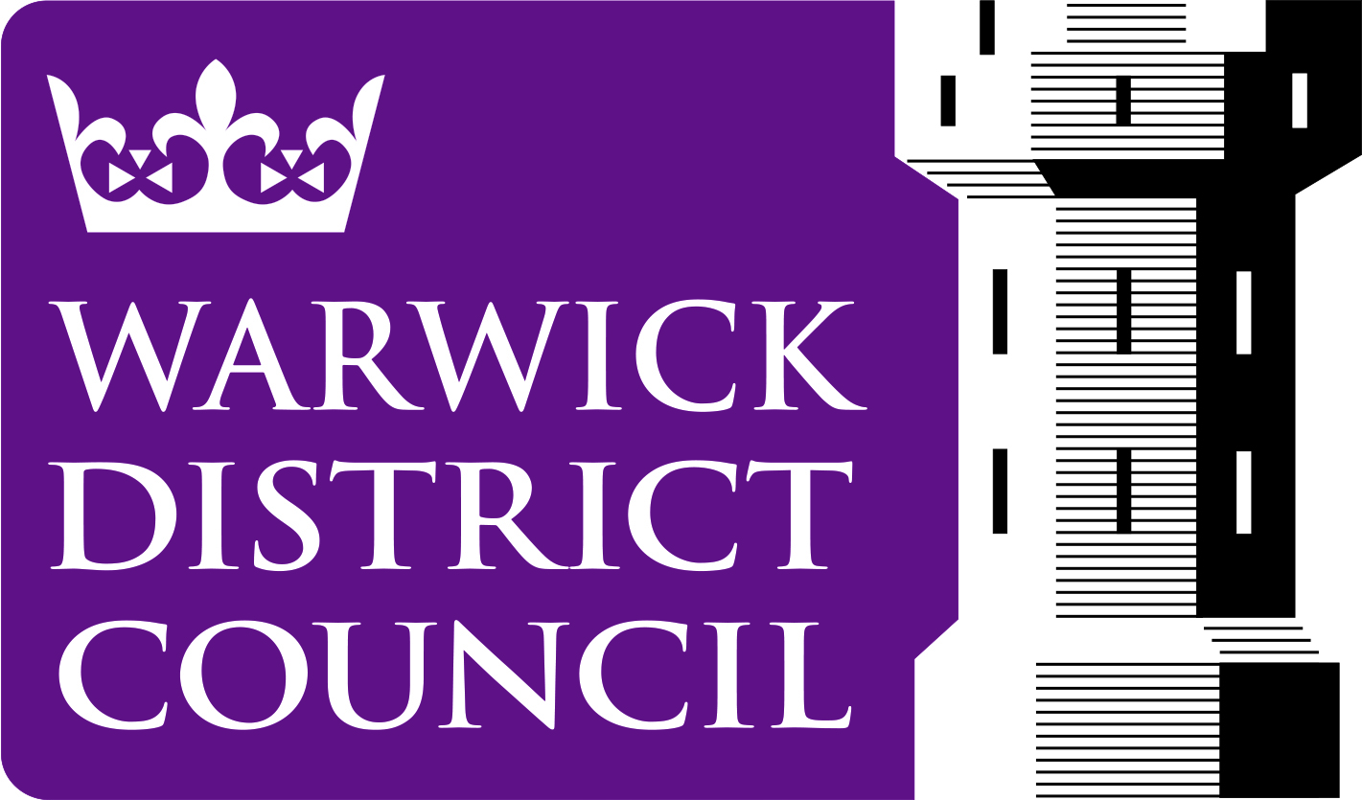

Development Services
12/19/2018

Community Infrastructure Levy

In April 2010 new regulations were introduced that allows local authorities to set up a Community Infrastructure Levy (CIL). CIL is a tariff charged on development, at a locally set rate, to fund infrastructure needs arising from new development. This can include transport schemes; flood defences; schools; health & social care facilities; parks & green spaces; cultural & sports facilities.
Warwick District Council (WDC) introduced their charging schedule on 18th December 2017; in order to ensure the levy is open and transparent, charging authorities must publish a report on the levy on their website by 31st December each year, for the previous financial year.

CIL Receipts

The purpose of CIL is to collect money to spend on infrastructure that the community needs; this can include transport schemes; education; health & social care facilities; parks & green spaces; cultural & sports facilities.

Once CIL receipts are received, the monies are divided into three areas:

- Strategic CIL – this is to be spent on items identified in WDC’s Regulation 123 list which can be found at https://www.warwickdc.gov.uk/downloads/file/4878/cil_reg_123_list

In this context WDC recognised that the relationship between the Reg. 123 List and the Infrastructure Delivery Plan (IDP) is vital. The IDP is underpinned by an evidence base which was prepared alongside the Local Plan. Schemes in the IDP have therefore been identified as being priorities to address the impact of growth. The current CIL Regulation 123 list was agreed by WDC Executive Committee in November 2017. When charging authorities wish to revise their regulation 123 list, they should ensure that any changes are clearly explained and subject to appropriate local consultation.

- Parish and Town Councils - this is passed directly to the Parish / Town Council where the development takes place

The amount passed to Parish / Town Councils can be up to 25% of the total CIL Receipts where a Neighbourhood Plan exists. Parishes / Towns without a Neighbourhood Plan will receive 15% (capped at £100 per existing Council Tax Dwelling). The CIL allocation must be spent to support the impact of developments on local communities, they must in turn report on their levy income and spending.

- Administration Expenditure – up to 5% of all CIL receipts can be retained for administration costs for the Levy by the charging authority.

WDC currently choose not to apportion the administration costs to them at the present time; a decision was taken to maximize the use of CIL income on infrastructure. Administration costs are therefore currently covered by WDC..

The table below sets out the CIL Reporting information as required by CIL Regulation 62 (4).

Regulation 62 reference | Description | Amount
4.(a) | Total value of CIL Demand Notices raised in 2017/18 | 0
 | Total CIL receipts for 2017/18 | 0
 | Total CIL payable in 2018/19 from Demand Notices issued in 2017/18. | 0
4.(b) | Total CIL expenditure in 2017/18 | 0
4.(c) (i) & (ii) | The items of infrastructure to which CIL (including land payments) has been applied and amount of CIL funded expenditure on each item -:  - Community / Leisure Infrastructure  - Transportation / Highways  - Green Infrastructure | 0  0  0
4.(c) (iii) | Amount of CIL applied to repay money borrowed, including any interest, with details of the infrastructure items which that money was used to provide (wholly or in part) | N/A
4.(c) (iv) | Amount of CIL applied to administrative expenses pursuant to regulation 61, and that amount expressed as a percentage of the CIL Demand Notices issued in that year in accordance with regulation 61. | N/A
4.(d) (i) | Total amount of CIL receipts retained at the end of the reported year. | 0

Further information about Warwick District Council Community Infrastructure Levy can be obtained from: https://www.warwickdc.gov.uk/info/20798/community_infrastructure_levy_cil

