Evidence paper – Parking Standards SPD

1.0 Introduction
1.1 The Parking Supplementary Planning Document (SPD) sets out the standards for parking for developments of different use classes across Warwick District. This document accompanies the SPD, and sets out the evidence which informed the development of those standards.
1.2 National Planning Policy Framework (NPPF) paragraph 39 requires Local Planning Authorities (LPAs) to take the following into account when setting local parking standards:
- The accessibility of the development
- The type, mix and use of development
- The availability of and opportunities for public transport
- Local car ownership levels
- An overall need to reduce the use of high emission vehicles

2.0 Residential parking
2.1 Table 1 of the Parking SPD sets out numeric standards for the number of allocated (usually on plot) parking spaces for dwellings of different sizes, and also a proportion of unallocated (usually on street) to provide space for visitors to park, and also to accommodate occasional individual households with a higher than average number of cars. These standards were designed based on the following evidence sources:
- Car ownership statistics across Warwick District
- Benchmarking parking standards developed by other Local Planning Authorities. This benchmarking exercise referred only to parking standards adopted following the introduction of the NPPF in 2012, as the NPPF brought about a key shift in national policy away from restrictive parking standards.
- Literature review of research into residential parking, most notably the survey evidence presented in ‘Space to Park’.
- Observational evidence from site visits

2.2 Car ownership in Warwick District
Table 1-1 Warwick District car ownership in context (based on 2011 census data)
 | % no cars in household | % 1 car per household | % 2 cars per household | % 3+ cars per household
England | 25.8 | 42.2 | 24.7 | 7.4
West Midlands | 24.7 | 41.5 | 25.8 | 8.0
Warwickshire | 17.6 | 40.9 | 31.3 | 10.2
Warwick District | 18.5 | 41.0 | 31.4 | 9.1

- Warwickshire and Warwick District car ownership figures are similar
- The % of households with no access to a vehicle is much lower at the county and district level than in the national and regional context.
- The % of households that have 2 or more vehicles is higher at the county and district level than the regional and national averages (particularly so in the % of households with two vehicles)

Table 1-2 Car ownership in Warwick District (based on census data)
Car or van availability | 2011 census |  | 2001 census
 | No. | % | No. | %
Without car/van | 10,848 | 18.5 | 10,341 | 19.4
With 1 car/van | 24,086 | 41.0 | 22,626 | 42.4
With 2 cars/vans | 18,413 | 31.4 | 16,332 | 30.6
With 3+ cars/vans | 5,332 | 9.1 | 4,067 | 7.6
All cars in area | 79,020 | - | 68,981 | -

- There is an upward trend in car ownership according to census data

Table 1-3 Car ownership by Ward
Ward | % of dwellings with no cars/vans per household | % dwellings with 1 car/van per dwelling | % dwellings with 2 cars/vans per dwelling | % dwellings with 3+ cars/vans
Abbey - Kenilworth | 15.44 | 40.65 | 34.62 | 9.29
Arden | 5.37 | 27.89 | 43.88 | 22.86
Aylesford | 16.97 | 42.99 | 33.56 | 6.61
Bishops Tachbrook | 7.84 | 37.32 | 42.70 | 9.21
Brunswick | 36.87 | 40.44 | 16.91 | 5.87
Budbrooke | 5.18 | 35.04 | 44.70 | 15.09
Clarendon | 30.97 | 43.93 | 19.95 | 5.18
Crown | 30.64 | 42.04 | 21.33 | 5.99
Emscote | 22.91 | 45.29 | 26.14 | 5.67
Leam | 27.55 | 44.51 | 21.79 | 6.15
Manor | 9.28 | 37.15 | 42.16 | 11.41
Milverton | 16.65 | 40.06 | 35.12 | 8.17
Myton &Heathcote | 6.43 | 38.31 | 43.91 | 11.39
Newbold | 21.72 | 42.86 | 28.21 | 7.22
Park Hill | 11.04 | 39.56 | 38.60 | 10.79
Radford Semele | 9.15 | 33.15 | 38.59 | 19.12
St Johns | 15.58 | 41.38 | 33.84 | 6.74
Saltisford | 26.64 | 47.68 | 21.60 | 4.12
Stoneleigh and Cubbington | 10.90 | 37.60 | 36.58 | 14.92
Sydenham | 26.49 | 45.22 | 23.43 | 4.86
Whitnash | 15.75 | 42.38 | 32.28 | 9.56
Woodloes | 16.07 | 45.47 | 30.41 | 8.05

(orange denotes lower than the district average, purple denotes higher than the district average)
2.3 Summary of key points on car ownership
- In predominantly rural wards, the % of dwellings with no cars can be up to a third less than the district average.
- Kenilworth wards also have a notably lower % of dwellings with no access to a car or van.
- Other more urban wards tend to have a higher % of households with no access to a vehicle.
- Brunswick ward has approx. double the no. of dwellings with no access to a car than the district average
- Clarendon and Crown wards have similar numbers of dwellings with no access to a car/van, at more than 50% above the district average
- Wards where the % of dwellings that have no vehicles is lowest tend to have higher than average ownership of 2 or more cars.

Benchmarking against Parking Standards from other Local Authority Areas

2.4 The table below compares the parking standards of other LPAs. As identified above, only LPAs that have produced parking standards since the adoption of the NPPF have been compared, as the NPPF brought about a significant shift in approach to the development of parking standards. Nearly all of the standards compared state minimum numbers of parking spaces.
Table 1-4 Residential benchmarking
C3 dwelling houses - size | Warwick DC 2007  (MAXIMUM spaces per dwelling) | Wychavon 2016 (interim standards)  (MINIMUM spaces per dwelling) |  | Northamptonshire 2016  (MINIMUM spaces per dwelling) |  | South Gloucestershire 2013 (MINIMUM spaces per dwelling) |  | Stratford - DRAFT  (standard spaces per dwelling)  **subject to consultation**
 |  | Allocated | Unallocated  (visitor) | Allocated | Unallocated  (visitor) | Allocated | Unallocated (visitor) | Allocated | Unallocated
1 bed | 1/unit | 1 (Flat with communal parking)  2** (House) | - | 1 | 1 | 1 | 0.2 | 1 | 0.4
2 bed | 1.5/unit | 2 (Flat with communal parking)  2** (House) | - | 2 | 1 | 1.5 | 0.2 | 2 | 0.4
3 bed | 2/unit | 2 ** | - | 2 | 1 | 2 | 0.2 | 2 | 0.4
4+ beds | 2/unit | 3 ** | - | 3 | 1 | 2 | 0.2 | 3 | 0.4
5+ beds | - | - | - | - | - | 3 | 0.2 | - | -
Retirement development |  |  |  | 1 | 0.5 |  |  | Residents -1/unit  Non-resident staff – ½ staff members | Visitors – 1/10 units
C4 - HMOs | 1/2 bedrooms |  |  | 1 space per bedroom

**garages excluded from minimum calculation due to ability to convert them to habitable accommodation without permission, and the fact they are often used for storage. The exception would be where they are equipped for electric vehicle charging, and a condition may be imposed ensuring its retention for the purposes of parking a vehicle.
Purpose Built Student Accommodation
2.5 The 2007 Vehicle Parking Standards SPD, does not define a parking standard for Purpose Built Student Accommodation (PBSA), and therefore to date each case has been considered on its own merits in respect of parking provision. Aspirations to explore the potential for a bespoke standard have been expressed, and therefore the evidence base that might support this has been looked into. The Parking Standards from the Local Authority Areas compared in table 1-4 above did not include PBSAs. This was found to be common to many Local Planning Authorities, which can commonly put down to either no/insignificant student populations, or the trend for LAs and Universities to actively seek to discourage students from bringing cars with them during their studies. Examples reviewed (adopted post NPPF) which were found not to include a bespoke standard for PBSAs (in addition to the above) include Brighton and Hove, Cumbria, Exeter, Buckinghamshire, Bath, Oxford, Worcestershire, Milton Keynes, Suffolk.
2.6 Other Local Authority areas that do have specific parking standards for PBSAs have therefore been compared below. All examples have been adopted since the introduction of the NPPF in line with other residential benchmarking.

Table 1-5
 | Swansea (March 2012)  (referenced in the 2017 HMO and PBSA SPD) | Plymouth (May 2013)  (Maximum standard) | Derby City (2013)
PBSA parking standard | 1 space/25 beds for servicing, wardens and drop off areas (zone 1)  1 space/25 beds for servicing, wardens and drop off areas + 1 space/10 beds for students and visitors (zones 2-6) | 1 space/2 occupiers | 1 space/ 4 bed spaces (at least 1 space per 15 bed spaces or less should be for ambulance or mini-bus parking and indicated as parking for disabled people)

2.7 Of those that were found to include bespoke standards, there is significant variation in the amount of parking spaces required, and it is unclear what evidential basis has been used in determining these standards. Swansea has adopted a zonal approach to its parking standards which clearly differentiates between central more accessible areas of the city, and those further toward the periphery.
2.8 The above highlights that relatively few local authorities specify parking standards for this land use. Furthermore, disparate results have emerged from the benchmarking above. In light of this, and the fact that the draft SPD is proposing a single standard for each use class/land use (i.e. it is not proposing to define zones and PBSAs on campus for example, might benefit from a different standard to those located in other areas of the district), it is considered that there is insufficient evidence to confidently design a standard for this land use at this time. There is a wider debate regarding the desirability of students bringing cars, and management arrangements for controlling and enforcing parking in PBSAs, which is beyond the scope of the SPD. In addition, there is concern that over-specifying parking standards could encourage greater numbers of students to bring cars, or result in large areas of underutilised land.
2.9 It is recommended therefore that each PBSA development proposal should continue to be considered on its own merits.

2.10 Summary of key points emerging from the benchmarking exercise
- Nearly all of the examples reviewed that were adopted post NPPF set out minimum residential parking standards.
- All of the minimum residential parking standards are equal to or (more commonly) greater than the maximum parking standards set out in WDC’s 2007 Vehicle Parking SPD.
- The majority of examples reviewed make specific provision for unallocated/visitor parking on a per dwelling basis. This is in addition to the allocated (usually on plot) provision.
- Garages are specifically excluded from inclusion in the parking standards in Wychavon, Northamptonshire and Stratford as all of these documents identify that garages are more commonly used for other purposes.
- There is significant variation in standards relating to PBSAs.

Literature review
2.11 A number of studies and examples from other areas have been reviewed as part of the process of drafting the Parking SPD, in order to get a complete picture of the updated evidence and best practice since the 2007 Vehicle Parking Standards were adopted. A full list is included in the bibliography.
2.12 With the adoption of the NPPF (2012) there has been a significant shift in national policy and advice in respect of car and vehicle parking. Before the NPPF, national policy required maximum parking standards, aimed at limiting car ownership with a view to encouraging alternative modes of travel. Current national policy and guidance (the NPPF and the Ministerial Statement, March 2015) recognises that this approach in isolation had little/no impact on car ownership, and has instead often created issues and tensions in neighbourhoods where parking provision does not meet demand.
2.13 In light of the above, new parking standards should not be designed to be restrictive, and it is considered likely that the 2007 (i.e. pre-NPPF) Warwick DC parking standards may be revised upward, with a view to meeting the higher than average demand evidenced by the car ownership data.
2.14 Key publications including Manual for Streets (2007) highlight the relative efficiency of unallocated on street car parking relative to allocated on plot parking. In summary, unallocated parking is more efficient in terms of use because it is flexible – i.e. it is available to all to use at the time of need, and not held empty in reserve for particular residents. In contrast, an on plot parking space dedicated to a particular property cannot be habitually used by others when the occupier is not parked there. Whilst this is well rehearsed and accepted, it is also acknowledged that there is significant market demand for on plot parking in residential development. As such, the SPD will set requirements for a mixture of both allocated and unallocated parking spaces. This reflects the pragmatic conclusions of the research contained within ‘Space to Park’, which surveyed numerous residential developments in respect of parking.
2.15 The benchmarking exercise set out above (table 1-4) illustrates that many of the adopted standards reviewed include a standard for unallocated parking on a per dwelling basis. Table 1-4 illustrates a range from 0.2 unallocated spaces per dwelling across the site to 1 unallocated space per dwelling, regardless of the size (no. of bedrooms) of the property. ‘Space to Park’ research concluded with a recommendation that 20% of the overall parking provision on new developments should be unallocated. Taking this information together, it is proposed that the SPD should provide for 20% of the number of allocated parking spaces to be provided unallocated across the site. This, it is concluded allows for better response to the housing mix of a development, which it is proposed (see Table 1 of the SPD), would directly impact on the number of allocated parking spaces.
2.16 Another key conclusion of the ‘Space to Park’ research was that cars were regularly parked in places where parking was not intended, and conversely that defined parking spaces were vacant in places. This relates to the perceived convenience and attractiveness of the relevant parking space. This can be attributed to two layout principles:
- The position of the space relative to a property - e.g. is it close to the entrance? Can residents see their car parked in the space from the dwelling?
- The dimensions of the space, and therefore the convenience of getting into the space and out of the vehicle.

2.17 In light of this evidence and observational evidence (see below), it is concluded that the new SPD should address design principles associated with the design and layout of parking provision.

Observational evidence

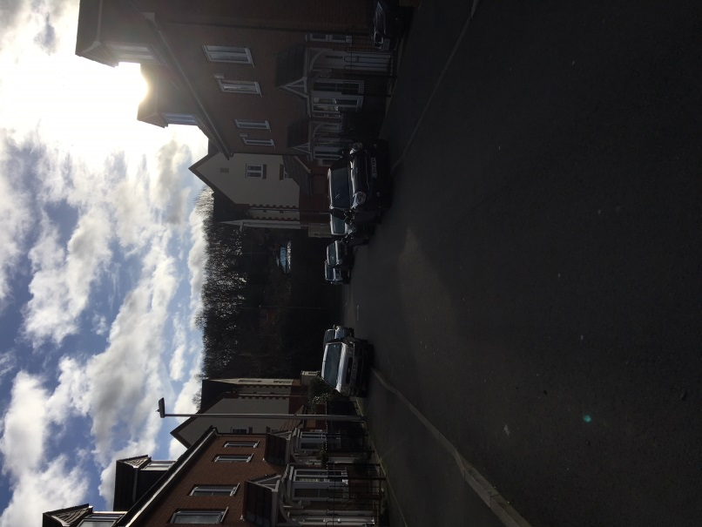
2.18 In researching the content of the SPD, officers undertook a number of site visits across the district. These were undertaken in normal office hours, when it is suggested that any residential parking issues are likely to be less acute (and therefore less obvious) than in the evenings or at weekends when greater numbers of people might be expected to be at home.
2.19 Whilst no two sites or places visited were the same, examples of developments where the amount of parking appeared to be insufficient were observed. One example is pictured left, where substantial parking over the footpath was observed.

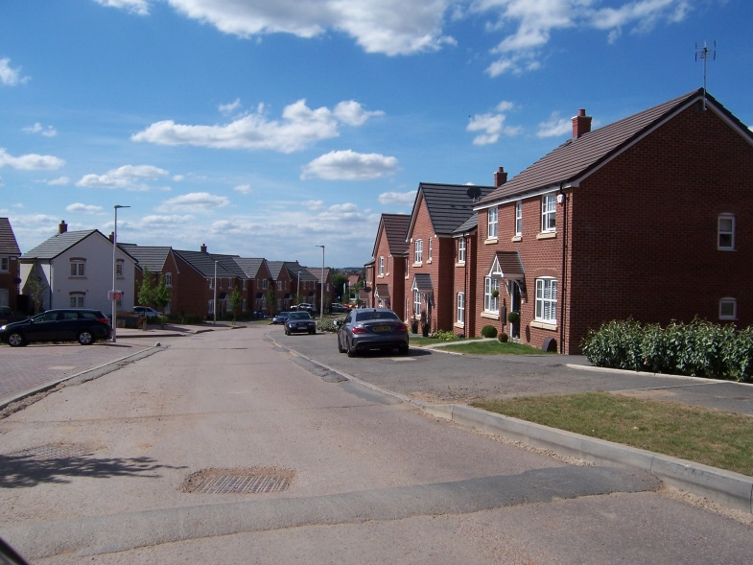
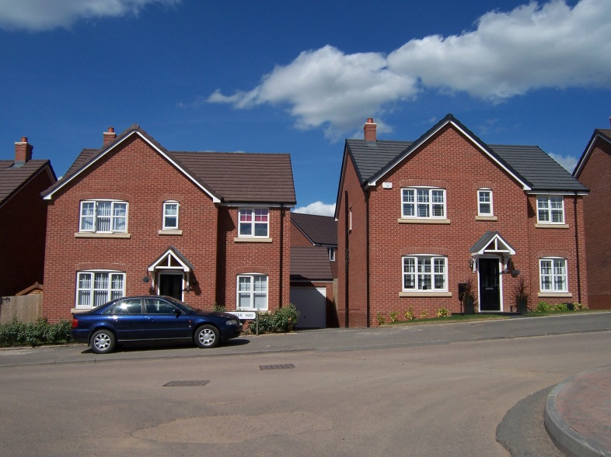
2.20 In addition to observations regarding the amount of parking, in some developments cars were observed parking in places where they were not intended on the design, whilst conversely designated parking spaces remained unused. For example, the recent development pictured right shows a car parked wholly on the footpath rather than being parked on the driveway. The photograph on the left illustrates that this behaviour was not discreet to one plot, but repeated along the street.

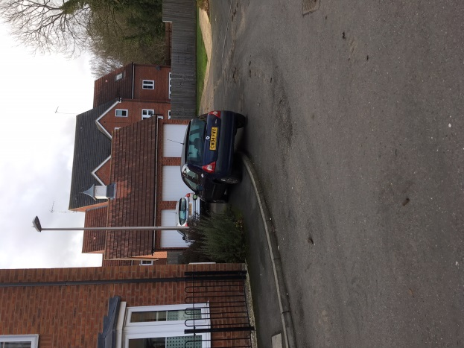
2.21 The photograph left was taken on the same development as the photograph on the previous page. Here too, designated spaces were observed unoccupied whilst cars were parked in other unintended positions. Whilst it was not possible from observation to ascertain the reasons for this, it can be assumed that they are likely to involve reasons of capacity and convenience. It was also clear on this and other site visits, that visitor parking has not been routinely incorporated into layouts, which might alleviate some of the issue observed in some places.

  - The observations on residential parking reflect the points highlighted in the literature review, and further support the conclusion that the SPD should address the dimensions and general position of the spaces relative to the property, in addition to the amount of parking provision.
Overall conclusions regarding residential vehicle parking
2.23 Recent residential parking standards (2012 onwards) generally incorporate minimum parking space numbers, which in turn are generally set higher than Warwick DC’s 2007 maximum standard. When this evidence is combined with the higher than average car ownership figures for the district, it is concluded that there is clear evidence to justify an increase in the amount of residential parking that should be required from new residential development. The standards set out in Table 1 of the SPD, have therefore been designed to increase the amount of parking required for residential development proposed in planning applications.
2.24 The standards set out in table 1 aim to accommodate an average demand. However, in light of variations across the wards of the district, there may be examples where a higher or a lower quantity of parking could be justified in the context of more localised evidence. These will need to be considered individually on their merits, and take account of the most recent available evidence, as for example car ownership and access to public transport are not static.

3.0 Non-residential vehicle parking

3.1 In determining the parking standards proposed in the SPD for each uses, a range of evidence has been considered. The evidence sources include:
- Benchmarking – Table 2-1 (below) sets out the existing or proposed parking standards for different non-residential use classes in the surrounding area. This enables direct comparison of parking standards, and serves to highlight where there is consistency and where there is disparity in standards for any given use class. The Parking standards selected were chosen because they met the following criteria:
- In the surrounding geographic area to Warwick District (or similar characteristics)
- Drafted/adopted since the publication of the NPPF in 2012, where the national policy approach to car parking provision shifted.
3.2 Furthermore comparison in the benchmarking table is based upon the land uses defined in the 2007 WDC Parking Standards SPD in the interests of consistency. Local Planning Authorities often group land uses differently within their parking standards.
- Documentary evidence – where relevant documentary evidence exists, this has been used to test parking standards set out in the 2007 Warwick Parking Standards, and where appropriate any proposed changes thereto.
- Observational evidence – as part of the process of drafting the SPD, officers undertook site visits to a number of recent developments. Where parking provision was observed to be insufficient, this is documented and used to inform any revised parking standard.

Benchmarking against other Local Authority areas
3.3 In contrast to the residential parking standards benchmarking; which demonstrates a comprehensive shift to minimum parking standards; comparison of non-residential parking standards (of which those in the table below are a few), highlights that there has not been a wholesale shift to minimum standards in these types of development. Whilst some have moved away from maximum standards, others have consciously continued with maximums as part of their attempts to encourage the use of alternative modes to ‘destinations’.
3.4 In addition, the benchmarking table below illustrates that for a number of use classes, the method of calculating parking numbers varies. For example, within D1 use-class some authorities have devised parking spaces based upon FTE job creation whilst others take a ‘per room’ approach. Within the C2 use class, parking standards for residential care homes are variously devised by a combination of FTE staff and bedrooms, or simply the number of bedrooms. This can make direct comparison of standards in some use classes challenging.
3.5 The benchmarking below is based upon the Use –class order, and specific land uses within some use –classes as defined in the 2007 Warwick DC Vehicle Parking Standards. It should be noted however, that in a number of cases the grouping of specific land uses and the specification of land uses in parking standards varies between different Local Authority Areas. The variation is most significant in the ‘D’ use classes.
Table 2-1 Non-residential parking benchmarking
Land use | Subcategory | Warwick DC (2007)  (expressed as maxima) |  | Northamptonshire  (2016 SPD)  (expressed as minima) | Stratford  DRAFT REVISIONS 2017  (approximate) | Rugby Draft LP  (expressed as maxima)
 |  | Low accessibility zone | High Accessibility zone |  |  | Low access | High Access
A1 - retail | - Food  - Non – food | 1/14sq.m  1/14sq.m | 1/50sq.m  1/50sq.m | 1/20sq.m  1/25sq.m | 1/15sq.m (up to 500sq.m gross floorspace)  1/10sq.m additional floorspace  1/20sq.m | 1/14sq.m  1/20sq.m | 1/50sq.m  1/50sq.m
A2 - Financial and professional services |  | 1/25sq.m | 1/50sq.m | 1/25sq.m | 1/20sq.m | 1/30 | 1/50
A3 – Restaurants and cafes |  | 1/20sq.m | 1/50sq.m | 1/14sq.m | 1/5sq.m | 1/5sq.m | 1/10
A4 – Drinking establishments |  | 1/20sq.m | 1/50sq.m | 1/14sq.m | 1/5sq.m | - | -
A5 – Hot food takeaway |  | 1/20sq.m | 1/50sq.m | 1/20sq.m | 1/5sq.m | - | -
B1 - Business | - B1(a)Offices  - B1(b) Research and development  - B1(c) Light industrial | 1/30sq.m  1/40sq.m  As above (b) | 1/60sq.m  1/80sq.m  As above (b) | 1/30sq.m | 1/20sq.m up to 1000sq.m floorspace  1/30sq.m additional floorspace  1/30sq.m up to 1000sq.m floorspace  1/40sq.m additional floorspace  As above (b) | 1/30  1/40  1/40 | 1/60  1/80  1/80
B2 – Light Industrial |  | 1/50sq.m | 1/100sq.m | 1/50sq.m | 1/30sq.m up to 1000sq.m floorspace  1/40sq.m additional floorspace | 1/45 | 1/90
B8 – Storage and distribution |  | 1/80sq.m | 1/160sq.m | 1/120sq.m | 1/50sq.m up to 1000sq.m floorspace  1/40sqm additional floorspace | 1/60 | 1/120
C1 Hotels and guesthouses |  | 1/bedroom | 0.5/bedroom | 1 per bedroom | Guests – 1/bedroom  Resident staff – 1/bedroom | 1/bedroom | 0.5/bedroom
C2 | Residential care home | 1/3 residents + provision for an ambulance | 1/4 residents + provision for an ambulance | 1 per full time equivalent staff + 1 visitor space per 3 beds | No standard | 1/4 residents | 0.5/4 residents
 | Hospital and treatment centres | Each case considered on its merits |  | 1 per 2 employees  1 per 3 beds for visitors  1 space per consulting for outpatients | No standard | Each case considered on its own merits
 | Residential education establishment – primary/secondary | Each case considered on its merits |  | 1 per full time equivalent staff | No standard | 1/4residents | 0.5/4residents
 | Residential education establishment – further/higher education | Each case considered on its merits |  | 1 per full time equivalent staff + 1 space per 5 students | No standard
D1 – Non-residential institutions | Medical, health, day centre | 4/consulting room | 2/consulting room |  | 3/consulting room for staff and visitors | 4/consulting room | 2/consulting room
 | Creche, child care | 1/FT staff | 0.5/FT staff | 1/FT staff; drop off/pick up at 1 per 4 participants | 1/staff member plus sufficient space for dropping off and collecting children | 1/FTE staff | 0.5/FTE staff
 | Schools, higher or further education | 2/classroom for staff and visitors; student/parent parking to be determined on merit | 1/classroom for staff and visitors; student/parent parking to be determined on merit | 1/FT staff + pro rata for part-time staff  Different standards for pupils and visitors depending on whether primary or secondary | 1/2 staff members | 2/classroom for staff and visitors  0 parking for parents dropping or collecting children | 1/classroom  0 parking for parents dropping or collecting children
 | Art gallery, museum, exhibition hall or library | 1/30sq.m | 1/60sq.m | 1/30sq.m | -
 | Public Hall or Places of Worship | 1/10sq.m or 1/5 seats(or person spaces)  (public halls considered on own merits) | 1/20sq.m or 1/10 seats/person spaces  (public halls to be considered on own merits | 1/30sq.m | - | 1/5 fixed seats or 1/10sq.m | 0.5/5 fixed seats or 0.5/10sq.m
D2 – Assembly and leisure | Cinemas, conference facilities, concert halls, theatres and other spectator facilities | 1/5 seats | 1/10 seats | 1/5 seats | 1/3 seats | 1/5 seats | 1/10 seats
 | Dance halls, discotheques and indoor play areas | 1/20 sq.m | 1/40sq.m | - | - | 1/22sq.m | 1/44sq.m
 | Bowling centres and bowling greens | 3/lane | 1.5/lane | - | - | 3/lane | 1.5/lane
 | Swimming pools, health clubs and gymnasia (+sports halls*) | 1/10sqm + 1/ 4 spectator seats (for both spectators and staff) | 1/20sqm + 1/8 spectator seats (for both spectators and staff) | 1/10sq.m public area | 1/20sq.m | 1/3 staff + 1/10sq.m pool and hall space | 0.5/3 staff + 1/10sq.m pool and hall space
 | Golf courses | 3/hole | n/a | 3/hole | - | 4/hole | -
 | Golf driving ranges | 2 spaces / tee | n/a | - | - | 2/tee | -
 | Marinas, sailing and water based uses, ice rinks | Each case considered on its own merits | Each case considered on its own merits | - | - | 1/1 staff + ½ participants | -
 | Tennis and badminton courts | 3 spaces / court | 1.5 / court | - | - | 3/ court | 1.5/court
 | Squash courts | 2 spaces / court | 1 / court | - | - | 3/court | 1.5/court
 | Playing fields | 12 / pitch plus motor coach space per pitch | 6 / pitch + motor coach space per pitch | - | - | 12/ ha of pitch area | 6/ha of pitch area
 | Stadia (referred to as ‘sports grounds’ in Rugby and Northamptonshire) | 1/15 seats + motor coach parking | n/a | 20/ pitch plus 1/5 spectator seats  Stadia – 1/FT staff + 1/15 spectators +coach parking | 1/20sq.m | 1/3 staff + 1/30sq.m playing area | 0.5/3 staff + 0.5/30sq.m playing area
 | Composite facilities and other sports and leisure facilities | Each case considered on its own merits based on the standards set out above. | Each case considered on its own merits based on the standards set out above. | - | -
Sui Generis | Garages, service stations and tyre/exhaust centres | 1/20sq.m | - | 1/FT staff + 1/35 sq.m | 2/50sq.m | 1/45sq.m for staff + 3/service bay for customers
 | Car showrooms | 1/50sq.m car display area |  | 1/45sq.m show area | 2/100sq.m including outdoor display areas. | 1/FTE staff + 1/10 cars on display for customers

Documentary evidence
3.6 A review of evidence which supported the development of the Local Plan was undertaken, in order to understand if any of it has implications for the review of the District’s parking standards.
3.7 The Coventry and Warwickshire Strategic Employment Study (2014) was found to contain some useful assumptions regarding the Full Time Equivalent (FTE) jobs anticipated from Gross Internal Floorspaces (GIA) for different B use classes. Whilst these assumptions may not be accurate for all developments within each use class, they enabled a testing of the existing standards in place since 2007, and have contributed to any justification to update standards in the new SPD (see table 2-2 below).
3.8 Table 4-1 on page 20 of the above document identifies the employment density assumptions, as set out below.
Use class | Employment density | Plot ratio
B1a/b | 12 sqm per FTE | 50% of site area
B1c | 47 sqm per FTE | 40% of site area
B2 | 36 sqm per FTE | 40% of site area
B8 | 70 sqm per FTE | 50% of site area

Observational evidence
3.9 As part of the research for revising the SPD, officers undertook a number of site visits across the district of different types of development.
Tournament Fields, Warwick
3.10 One of the most striking site visits was Tournament Fields, where insufficient parking was observed to accommodate the evident demand on a mid-week afternoon in July, despite the corresponding planning permissions demonstrating that the maximum parking standards set out in the 2007 SPD were largely achieved. Tournament Fields comprises a mix of predominantly B1 uses.
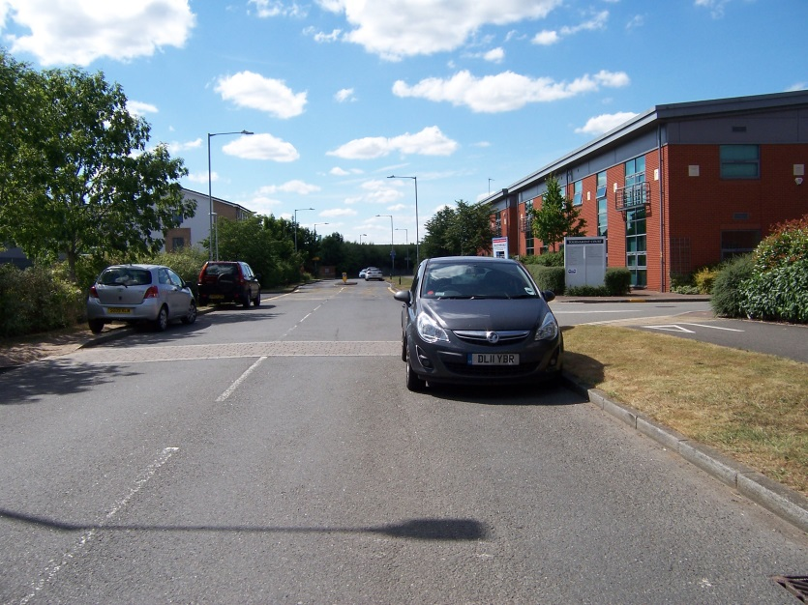
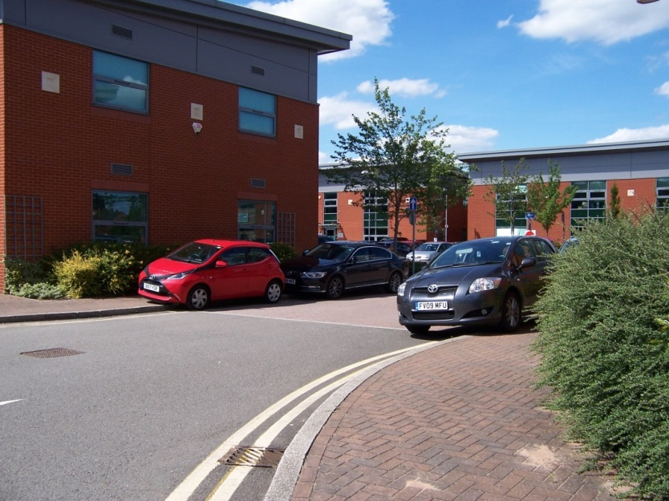
Photographs taken at Tournament Fields

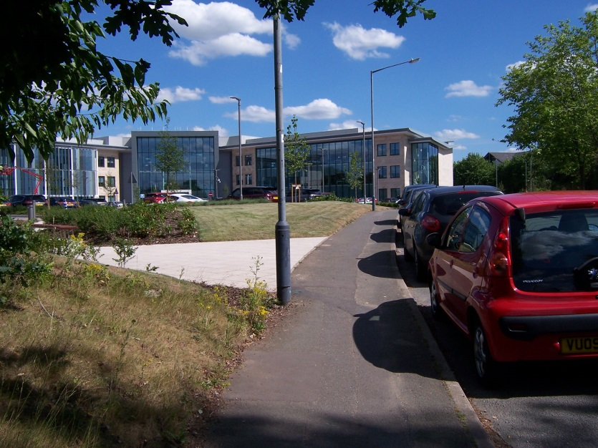
Tachbrook Park was another location where additional on street parking was observed.

Conclusions from the evidence
3.11 Table 2-2 below sets out the 2007 parking standards (based on the low accessibility figures- see below), and the parking standards set out in the draft SPD. Alongside this information is an explanation how and why the parking standards have been proposed as set out in the SPD.
3.12 The standard for ‘low accessibility zones’ has been used for comparison in table 2-2. This reflects the proposal not to distinguish between ‘low accessibility’ and ‘high accessibility zones’ in the draft SPD. Instead, the SPD sets out that a flexible approach to parking will usually be acceptable within the town centres of Leamington Spa, Warwick and Kenilworth within the town centres as defined in the Local Plan. This primarily results from the rationale that a significant proportion of non-residential developments within the designated town centres are unlikely to be changes of use and alterations to existing buildings rather than significant new build, and thus would be unable to provide stand-alone parking. Instead these developments would often expect to utilise existing town centre parking. Furthermore, a more flexible approach is likely to be appropriate due to the relative accessibility of the town centres by other modes.
Table 2-2 Justification for proposed parking standards
Use class | Land use | 2007 Maximum Parking Standard | Proposed parking standard | Justification
A1 | Non – food retail | 1 space /14sq.m | 1 space/14sq.m | - The benchmarking exercise shows some relatively significant differences in parking standards for this use class with WDC’s existing standard being the highest.
 | Food retail | 1 space / 14sq. m | 1 space / 14sq.m | - The benchmarking exercise shows some variation in standards for this use class, with WDC’s existing standard being the highest. With the exception of Northamptonshire however, the variation is not considered significant.
A2 | Financial and business services | 1 space / 25sq.m | 1 space/ 25sq.m | - The benchmarking exercise highlights some variation in standards for this use class, with Stratford’s (draft) standard being higher, and Rugby’s lower, and Northamptonshire’s being similar to the 2007 WDC standard.
A3 | Restaurants and cafes | 1 space/20sq.m | 1 space/20sq.m | - The benchmarking exercise shows significant variation in parking standards for this use class, with WDC’s 2007 standard being significantly lower than any of the surrounding local authority areas.
A4 | Drinking establishments | 1 space/20sq.m | 1 space /20sq.m | - The benchmarking exercise shows significant variation in parking standards for this use class, with WDC’s 2007 standard being significantly lower than any of the surrounding local authority areas.
A5 | Hot Food Takeaway | 1 space/20sq.m | 1 space / 20sq.m | - There is also some significant variation within standards for this use class. However, Northamptonshire’s standard is similar to the existing WDC standard.

Use class | Land use | 2007 Maximum Parking Standard | Proposed parking standard | Justification
B1 (a) | Offices | 1 space/30sq.m | 1 space/20sq.m GIA up to 1000sq.m, then 1 space/30sq.m additional floor space. | - Benchmarking shows relative consistency in parking standards for this land use (albeit that there is variation in whether the standard represents maxima/minima/approximate standard). Stratford District Council has however proposed a higher parking standard for this land use.  - The Coventry and Warwickshire Strategic Employment Study (2014), suggests that as a rule of thumb, approximately 1 ‘full time equivalent’ (FTE) job exists for every 12sq.m of the Gross Internal Floor space (GIA) in this use-class. On this basis, the 2007 WDC standard approximately equates to 0.4 parking spaces per FTE job. This is considered to be low when compared with other use classes.  - It has been observed by officers on site visits that there regularly seems to be insufficient car parking provision associated with recent B1 (predominantly office) developments, leading to unintended on street parking in the surrounding area, including residential streets. For example, photographs of parking not intended in the layout design on Tournament fields are included in the observational evidence. This is despite the respective elements of the larger site regularly delivering the 2007 maximum parking standard.  - The second and third points above both point to a need to increase the amount of parking provided for B1 (a) developments. The proposed standard would approximately create 0.6 spaces per FTE (an uplift of 50% on the 2007 standard).
B1 (b) | Research and development | 1 space/ 40sq.m | 1 space/20sq.m GIA up to 1000sq.m, then 1 space/30sq.m additional floor space. | - Benchmarking shows that standards in respect of this use class are either stated as 1/40sqm or 1/30sqm. WDC’s 2007 standard is therefore at the lower end of the standards considered in the study, and suggests scope to increase this.  - The Coventry and Warwickshire Strategic Employment Study (2014), suggests that as a rule of thumb, approximately 1 ‘full time equivalent’ (FTE) job exists for every 12sq.m of the Gross Internal Floor space (GIA) in this use-class. On this basis, the 2007 WDC standard approximately equates to 0.3 parking spaces per FTE job. This is considered low when compared with other use classes.  - It has been observed by officers on site visits that there regularly seems to be insufficient car parking provision associated with recent B1 (predominantly office) developments, leading to unintended on street parking in the surrounding area, including residential streets. For example, photographs of parking not intended in the layout design on Tournament fields are included in the observational evidence. This is despite the respective elements of the larger site regularly delivering the 2007 maximum parking standard.  - The second and third points above both point to a need to increase the amount of parking provided for B1 (b) developments. Given that as outlined under the second point above, the ratio of FTE jobs to GIA is stated as the same as use class B1(a), the proposed parking standard is the same as that for B1(a).
B1 (c) | Light industrial | 1 space / 40sq.m | 1 space/40sq.m | - The benchmarking exercise illustrates some differences in the parking standards for this use class, which are set at either 1 space / 40 sq.m or 1 space / 30 sq.m (the same as B1(b) above).  - The Coventry and Warwickshire Strategic Employment Study (2014) suggests that as a ‘rule of thumb’, approximately 1 FTE job exists for every 47sq.m GIA under this use-class. On this basis, the existing parking standard equates to 1.175 spaces per FTE job. This is considered too high in the context of other standards.  - On the basis of the above, this is the only use class where a slight decrease from the existing standard is proposed.
B2 | Light Industrial | 1 space/50sq.m GIA | 1 space/50sq.m GIA | - Benchmarking shows relative consistency across three Parking Standards, however North Warwickshire’s draft standard is significantly lower (50% lower) and Stratford’s draft standards are significantly higher.  - The Coventry and Warwickshire Strategic Employment Study (2014) suggests that as a rule of thumb in this use class 1 FTE job equates to 36sq.m GIA. On this basis, adopting a 1 space/50sq.m GIA would deliver approximately 0.72 parking spaces per FTE job, which is considered reasonable.  - There have been no significant observations of insufficient parking associated with B2 development.  - On the basis of all of the above, it is concluded that an approximate parking standard of 1 space/50sq.m GIA should be proposed.
B8 | Storage and Distribution | 1 space/80sq.m GIA | 1 space /80sqm | - Benchmarking illustrates significant disparity between parking standards for this use class, ranging from 1 space/50sq.m GIA to 1 space/150sq.m GIA.  - The Coventry and Warwickshire Strategic Employment Study (2014) suggests that 1FTE job equates to 70sq.m GIA. This effectively means that the 2007 standard equates to 0.875 parking spaces per FTE job.  - There have been no significant observations of insufficient parking associated with existing B8 developments.

Use class | Land use | 2007 Maximum Parking standard | Proposed parking standard | Justification
C1 | Hotels and guest houses | 1 space / bedroom | 1 space / bedroom | - The benchmarking exercise demonstrates relative parity across the parking standards considered in this use class.
C2 | Residential care home | 1 space / 3 residents + space for an ambulance | 1 space / 3 residents  + space for an ambulance | - The benchmarking exercise illustrates some variation in standards for this use class, with some separating staff and visitor parking needs.

Use class | Land use | 2007 Maximum parking standard | Proposed parking standard | Justification
D1 (non-residential institutions) | Consulting rooms (doctors, dentists, vets) | 4 spaces / consulting room | 4 spaces / consulting room | - Benchmarking suggests relative consistency across the standards considered. Rugby’s proposed standard matches WDC’s 2007 standard, with the standard cut by 50% in ‘accessible areas’. Stratford DC’s draft standard takes the middle ground and requires 3 spaces / consulting room.  - There have been no significant observations regarding the existing parking standard, and it seems logical based on accommodating staff and patients/visitors.
 | Crèche, day nursery, day centre | 1 space / FTE staff | 1 space / FTE staff + space for dropping off and collecting children as appropriate. | - Benchmarking suggests relative consistency in standards applied to this land use, with some requiring “sufficient space” for dropping off and collecting children.  - The proposed standard is similar to the existing standard, with the exception that it is no longer expressed as a maximum. The inclusion of drop off/pick up spaces is considered to reflect an obvious likely need, though it is no quantified and will need to be considered on merit.
 | Schools | 2 spaces / classroom for staff and visitors.  + facilities for picking up and setting down children or as determined by Travel Plan. | 2 spaces / classroom for staff and visitors.  + facilities for picking up and setting down children or as determined by Travel Plan. | - The benchmarking exercise illustrates that standards in respect of schools and higher education can be expressed differently. However, all standards are expressed to accommodate staff and visitors only and either rule out parent/student parking or suggest each case will be considered on its own merit in this respect.
 | Higher and further educational establishments | 2 spaces / classroom for staff and visitors;  Student/parent parking to be determined on merit or according to Travel Plan | 2 spaces / classroom for staff and visitors;  Student/parent parking to be determined on merit or according to Travel Plan | - The benchmarking exercise illustrates that standards in respect of schools and higher education can be expressed differently. However, all standards are expressed to accommodate staff and visitors only and either rule out parent/student parking or suggest each case will be considered on its own merit in this respect.
 | Art galleries, museums and libraries | 1 space / 30sqm | 1 space / 30sqm | - The benchmarking exercise revealed that not many LPAs have a specific standard for this type of land use. Northamptonshire’s standard matched WDC’s 2007 standard (though it is stated as a minimum rather than a maximum).
 | Places of Worship | 1 space / 10sqm or 5 seats/person spaces | 1 space / 10sqm or 5 seats/person spaces | - No all parking standards compared separate this land use out specifically. Amongst those that do, there is some differences, except Rugby BC is currently proposing a standard identical to the existing Warwick DC standard. Therefore propose to retain the standard in the same format.
 | Public halls, exhibition halls etc | To be considered on own merits | To be considered on own merits | - The 2007 WDC standards do not specify a level of parking for public halls. There is not considered to be sufficient evidence to determine a consistent approach and therefore no specific standard is proposed for this land use.
D2 - Assembly and leisure | Cinemas, conference facilities, concert halls, theatres and other similar spectator facilities | 1 space / 5 seats | 1 space /5 seats | - 1/5 seats is replicated in other examples in the benchmarking exercise. Only Stratford has produced a higher standard 1/3
 | Dance halls, discotheques and indoor play areas | 1 space / 20sqm | n/a | - The benchmarking exercise illustrates that only WDC and Rugby BC have separated this land use out, and the standards are identical. As planning applications for these uses are infrequent, it is proposed that this land use does not have a defined parking standard and each case is considered on its own merits.
 | Bowling centres, bowling greens | 3 spaces / lane | n/a | - The benchmarking exercise illustrates that only WDC and Rugby BC have separated this land use out, and the standards are identical. As planning proposals for this type of development are infrequent, it is proposed that this specific land use does not have a bespoke parking standard and that instead each case is considered on its own merits.
 | Swimming pools, health clubs and gymnasia | 1 space / 10sqm + 1 space / 4 spectator seats | 1 space / 10sqm + 1 space / 4 spectator seats | - Parking standards for this type of land use are shown to be expressed differently within the benchmarking exercise, making direct comparison challenging. Propose to retain the existing numerical standard, as no alternative evidence convincingly evidences a need to change it at this time. As set out below in this table, it is proposed that other specific indoor sports land uses are also incorporated into this standard.
 | Golf courses | 3 spaces / hole | 3 spaces / hole | - 3 spaces / hole is the standard Northamptonshire adopt also, though Rugby BC proposes a slightly higher standard at 4 spaces/hole……
 | Marinas, sailing and water based uses, ice rinks | Each case considered on own merits | n/a | - The benchmarking exercise has illustrated that most Parking Standard policies do not separate this land use out within the D2 use class for its own bespoke standard. Given that examples of this type of development proposal are likely to be infrequent, it is considered appropriate to continue to assess these cases on their own merits.
 | Tennis and badminton courts | 3 spaces / court | n/a | - The benchmarking exercise has illustrated that other parking standard policy documents do not commonly separate out these land uses within the D2 use class. Instead, more commonly playing courts such as these are encompassed within an ‘indoor sport’ category, though within this there is no consistent approach to the parking standard set out.  - It is proposed that no bespoke standard for these types of development. Instead these would come under an amended group of land uses incorporating indoor sports halls and other indoor leisure pursuits.
 | Squash courts | 2 spaces / court | n/a
 | Playing Fields | 12 spaces / pitch plus motor coach space /pitch | 12 spaces / pitch plus motor coach space  **other facilities such as club houses and bars must be considered separately | - The benchmarking exercise has illustrated that other parking standard policy documents do not commonly separate out this land use within the D2 use class or refer to it separately as ‘sports grounds’ (table ). It is proposed to retain the existing standard on this basis, but to highlight in a clearer fashion that other facilities on site should be subject to separate parking calculations.
 | Stadia | 1 space / 15 seats + motor coach parking
 | Composite facilities and other sports and leisure facilities | Each case considered on its own merits based on the standards above. | Calculate a total amount of parking based on the parking standards for each use class and land use therein. | - As outlined under various land uses within the D2 use class above, few other examples examined as part of this process separate out as many land uses as the 2007 Warwick DC SPD. Instead, it is observed that parking standards are commonly proposed for “indoor and outdoor sports facilities”. Given that there is little evidence to corroborate or otherwise the existing standards, it is instead proposed that a broader standard is proposed for indoor and outdoor sports. Where specific sports uses are proposed, an applicant may be able to justify higher or lower parking provision than set out within the new standard.  - It is proposed that the requirement to consider different elements of a scheme separately will be highlighted within the new SPD. For example club houses and bars which may be hired need to calculate parking requirements in the relevant use class and factor this into the calculation.
Sui Generis | Vehicle repair, garage and spares stores | 1 space / 20sqm | 1/20 sqm | - Some variation in the calculation of parking provision for this land use is evident in the benchmarking exercise. It is proposed therefore that the existing standard is retained.
 | Car sales establishments | 1 space / 50sqm car display area | 1 space / 50sqm car display area | - The benchmarking exercise shows that the WDC 2007 standard is similar to that proposed in new standards by both Northamptonshire and Stratford DC, albeit the later are expressed as a standard or minimum whereas the former is a maximum.
 | Exhaust and tyre centres | 1 space / 0.3-0.5 bays | 1 space / 0.3-0.5 bays | - Other parking standards compared do not regularly distinguish this land use. Proposed to retain as is.
Non-residential Cycle Parking - benchmarking
3.13 Warwick DC 2007 cycle parking standards are minimums as they are in all standards reviewed from elsewhere. Cycle parking standards are compared in the benchmarking table below. It should be noted that land uses in the existing parking SPD (2007) are not the same for car parking and cycle parking. Instead fewer land uses are specified and tailored more to the use class.
Use class | Subcategory | Warwick (2007)– MINIMUM standard | Northamptonshire MINIMUM (2016) | Stratford upon Avon (2007) MINIMUM | Rugby Local Plan – Submission document (MINIMUM)
 |  |  |  |  | Long stay - staff | Short stay - visitors
A1 | Food and non-food | 1/150sq.m | 1/200sq.m for staff and 1/200sq.m for customers | 1/200sq.m | Greater of 1/6 staff or 1/300sq.m | 1/200sq.m
A2 | Financial and Professional Services | 1/150sq.m | 1/100sq.m for staff + 1/200sq.m for customers | 1/200sq.m | Greater of 1/6 staff or 1/300sq.m | 1/200sq.m
A3 | Restaurants and cafes | 1/150sq.m | 1/60sq.m for staff + 1/60sq.m for customers | 1/60sq.m (excluding associated residential accommodation) | Greater of 1/6 staff or 1/40sq.m | 1/20sq.m
A4 | Drinking establishments | 1/150sq.m | 1/60sq.m for staff + 1/60sq.m for customers | 1/60sq.m (excluding associated residential accommodation) | - | -
A5 | Hot food takeaways | 1/150sq.m | 1/60sq.m for staff + 1/60sq.m for customers | 1/60sq.m (excluding associated residential accommodation) | - | -
B1 | Business (offices, research and development and light industry) | 1/200sq.m | 1/100sq.m for staff + 1/200sq.m for customers | 1/200sq.m | 1/150sq.m (B1(a)) or 1/250sq.m (B1(b) and (c)) | 1/500sq.m
B2 | General industry | 1/500sq.m | 1/200sq.m for staff + 1/200sq.m for customers | 1/500sq.m | 1/350sq.m | 1/500sq.m
B8 | Storage and distribution | 1/850sq.m | 1/500sq.m for staff + 1/1000sq.m for customers | 1/1000sq.m | 1/500sq.m | 1/500sq.m
C1 | Hotels | 1/4bedrooms | 1/5staff + 1/5bedrooms | 1/5staff  1/10 guest rooms  1/60sq.m restaurant/entertainment area | 1/6 FTE staff | 1/10 beds
C2 | Accommodation for people in need of care (hospitals/care homes/residential institutions) | To be considered on own merits | - | - | 1/6 FTE staff | Minimum 2/establishment
D1 | Medical | 1/350sq.m or 1/3consulting rooms | 1/4staff + 1/consulting room | 1/3consulting rooms | Greater of 1/2consulting rooms or 1/6 staff | 1/consulting room
 | Nurseries | To be considered on own merits | 1/4staff + 1/10child spaces | 1/5staff + 1/200sq.m for visitors | 1/6 FTE staff  Minimum 2/establishment
 | Educational | To be considered on own merits | 1/4staff + 1/10% of pupils | 1/5staff + 1/3 students | Each case considered on own merits
 | Art galleries, museums, public/exhibition hall, places of worship and libraries | To be considered on own merits | 1/4staff + 1/50sq.m for visitors | 1/10seats | Greater of 1/6 staff or 1/40sq.m (POW)  Other land uses considered on own merits | 1/20sq.m (POW)  Other land uses considered on own merits
D2 | Assembly and leisure | To be considered on own merits, however where 20 or more car park spaces are provided there should be 10% cycle parking provision. | 10 spaces + 1/10 vehicle spaces. | 1/5staff + 1/100sq.m | Greater of 1/6 staff or 1/40sq.m | 1/20sq.m

Bibliography
Brighton and Hove Policy CP21 available: https://www.brighton-hove.gov.uk/sites/brighton-hove.gov.uk/files/CP21.pdf
Cambridge City Council (2010) Cycle Parking Guide for new residential developments
Coventry and Warwickshire Strategic Employment Study (2014) available at: https://www.warwickdc.gov.uk/downloads/file/2328/ec01_-_coventry_and_warwickshire_local_enterprise_partnership_strategic_employment_land_study_-_october_2014
Department for Communities and Local Government (DCLG). 2012. National Planning Policy Framework. Available at: https://www.gov.uk/government/publications/national-planning-policy-framework--2
Department for Transport (DfT). 2007. Manual for Streets. Available at: https://www.gov.uk/government/uploads/system/uploads/attachment_data/file/3891/pdfmanforstreets.pdf
English Partnerships (2008) Car Parking. What works where
Lambeth Council (2012) Parking Survey Guidance Note
Lifetime Homes: http://www.lifetimehomes.org.uk/
Ministerial Statement (March 2015) https://www.gov.uk/government/speeches/planning-update-march-2015
Northamptonshire County Council (2016) Parking Standards. Available at: http://www3.northamptonshire.gov.uk/councilservices/northamptonshire-highways/transport-plans-and-policies/Pages/northamptonshire-parking-standards.aspx
Plymouth (2013) Development Guidelines available at: http://www.plymouth.gov.uk/sites/default/files/DevelopmentGuidelinesSupplementaryPlanningDocumentFirstReview.pdf
Rugby Borough Council Local Plan – Submission Version 2017
Southwark Council () Residential parking survey methodology
Space to Park: http://www.spacetopark.org/
Stratford District Council Cabinet Report: Parking Standards. 15 January 2018
Sustrans (2004) Cycle Parking information sheet FF37
Swansea City Council (2012) Parking Standards SPD available: https://www.swansea.gov.uk/spg
Swansea City Council (2017) Houses in Multiple Occupation and Purpose Built Student Accommodation SPD available: https://democracy.swansea.gov.uk/documents/s35526/05%203%20of%204%20-%20Appendix%202a%20SPG%20on%20HMOs%20and%20PBSA%20July%202017_For%20approval%20by%20Planning%20Committee.pdf
Telford and Wrekin Council (2016) Parking Standards
Telford and Wrekin Council (2016) Parking Standards – Evidence Base
Transport for London (2006) Workplace cycle parking guide
Warwick District Local Plan 2011-2029 (adopted September 2017)
Warwick District Council (2012) HMO Article 4 Direction
Warwickshire Observatory (2013) 2011 Census Key Messages, Warwick District. Available at: https://apps.warwickshire.gov.uk/api/documents/WCCC-1014-142
Warwickshire Observatory. Indicator data, Vehicle Ownership for 2015 Electoral Wards. Available at: http://maps.warwickshire.gov.uk/IAS/dataviews/tabular?viewId=337&geoId=3740&subsetId=
Wychavon Interim Parking Standards (2016). Available at: https://www.wychavon.gov.uk/documents/10586/1811948/APPENDIX+-+Interim+Parking+Standards+Adopted.pdf/e603f396-028a-4db1-ba09-9f9326076b77

